**Dropbox- Lab 2**

**Dropbox Functionalities Implemented:**

1. **Signup new user**

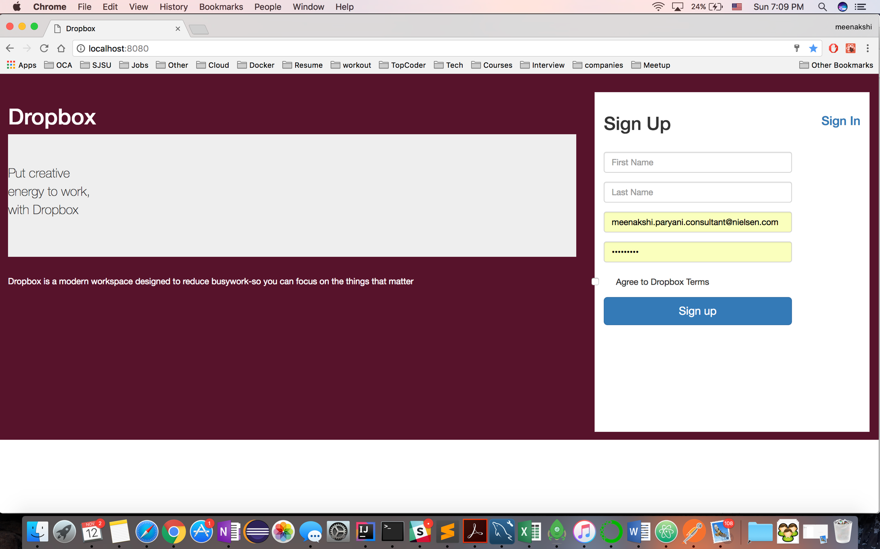

1. **Sign In existing user**

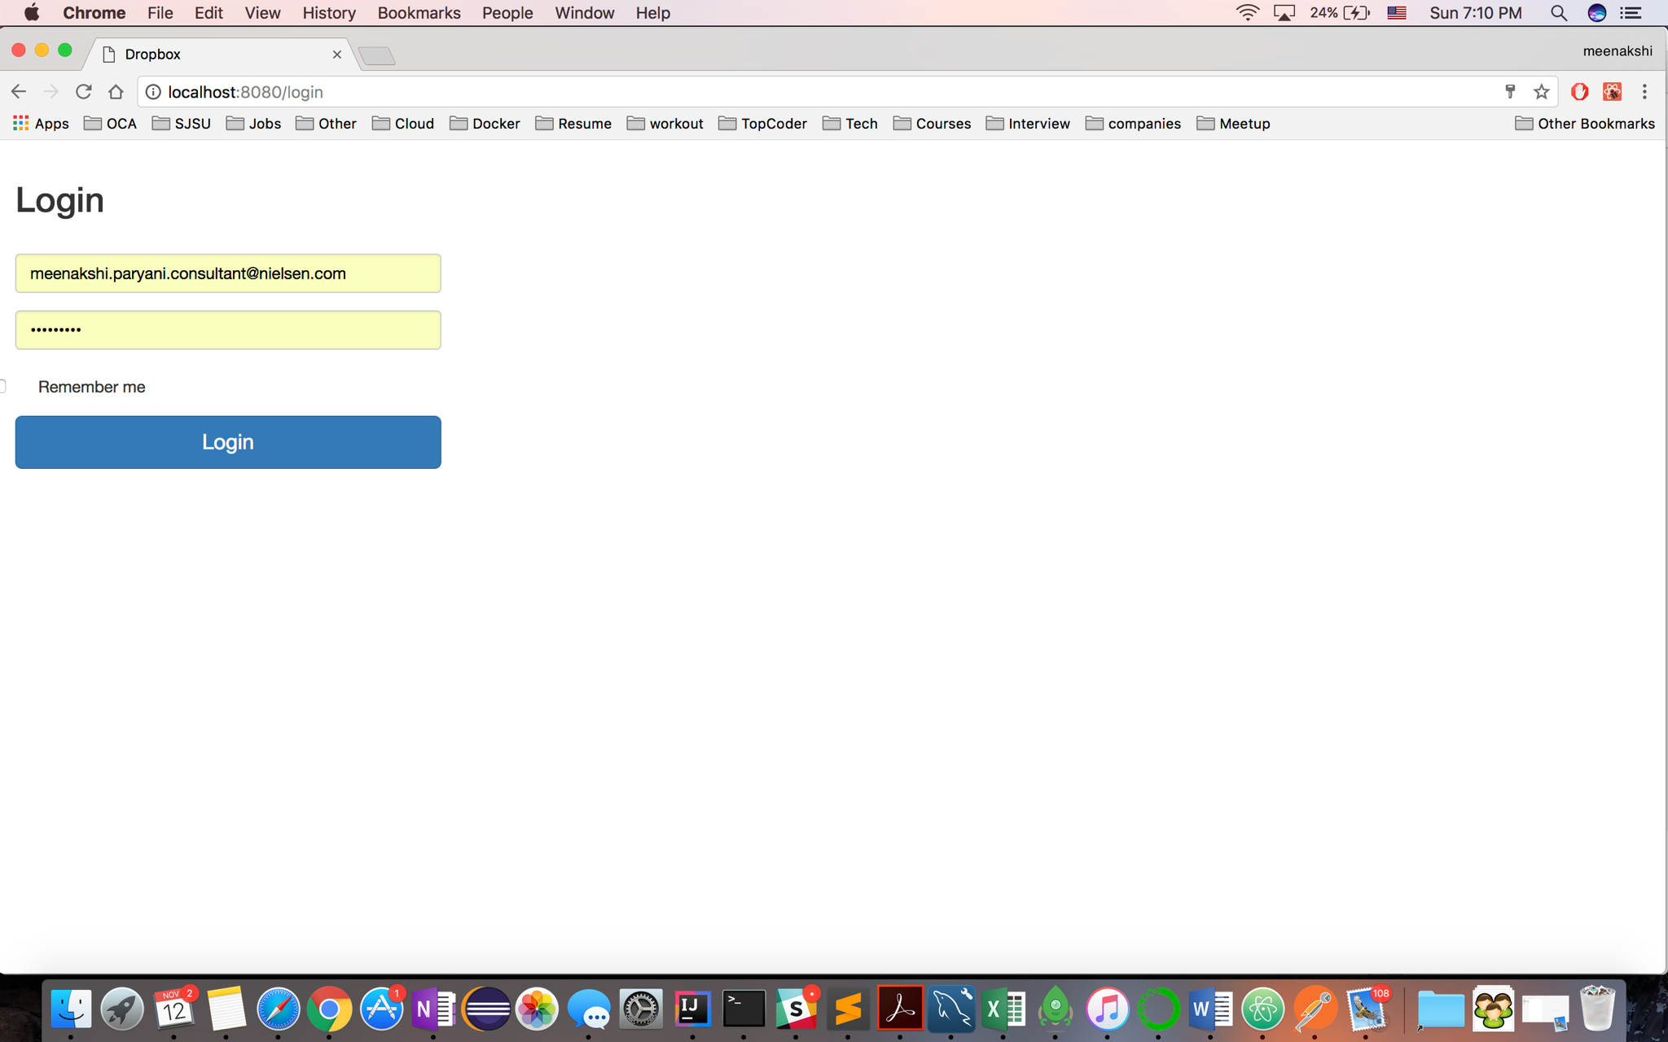

1. **Password Encryption**

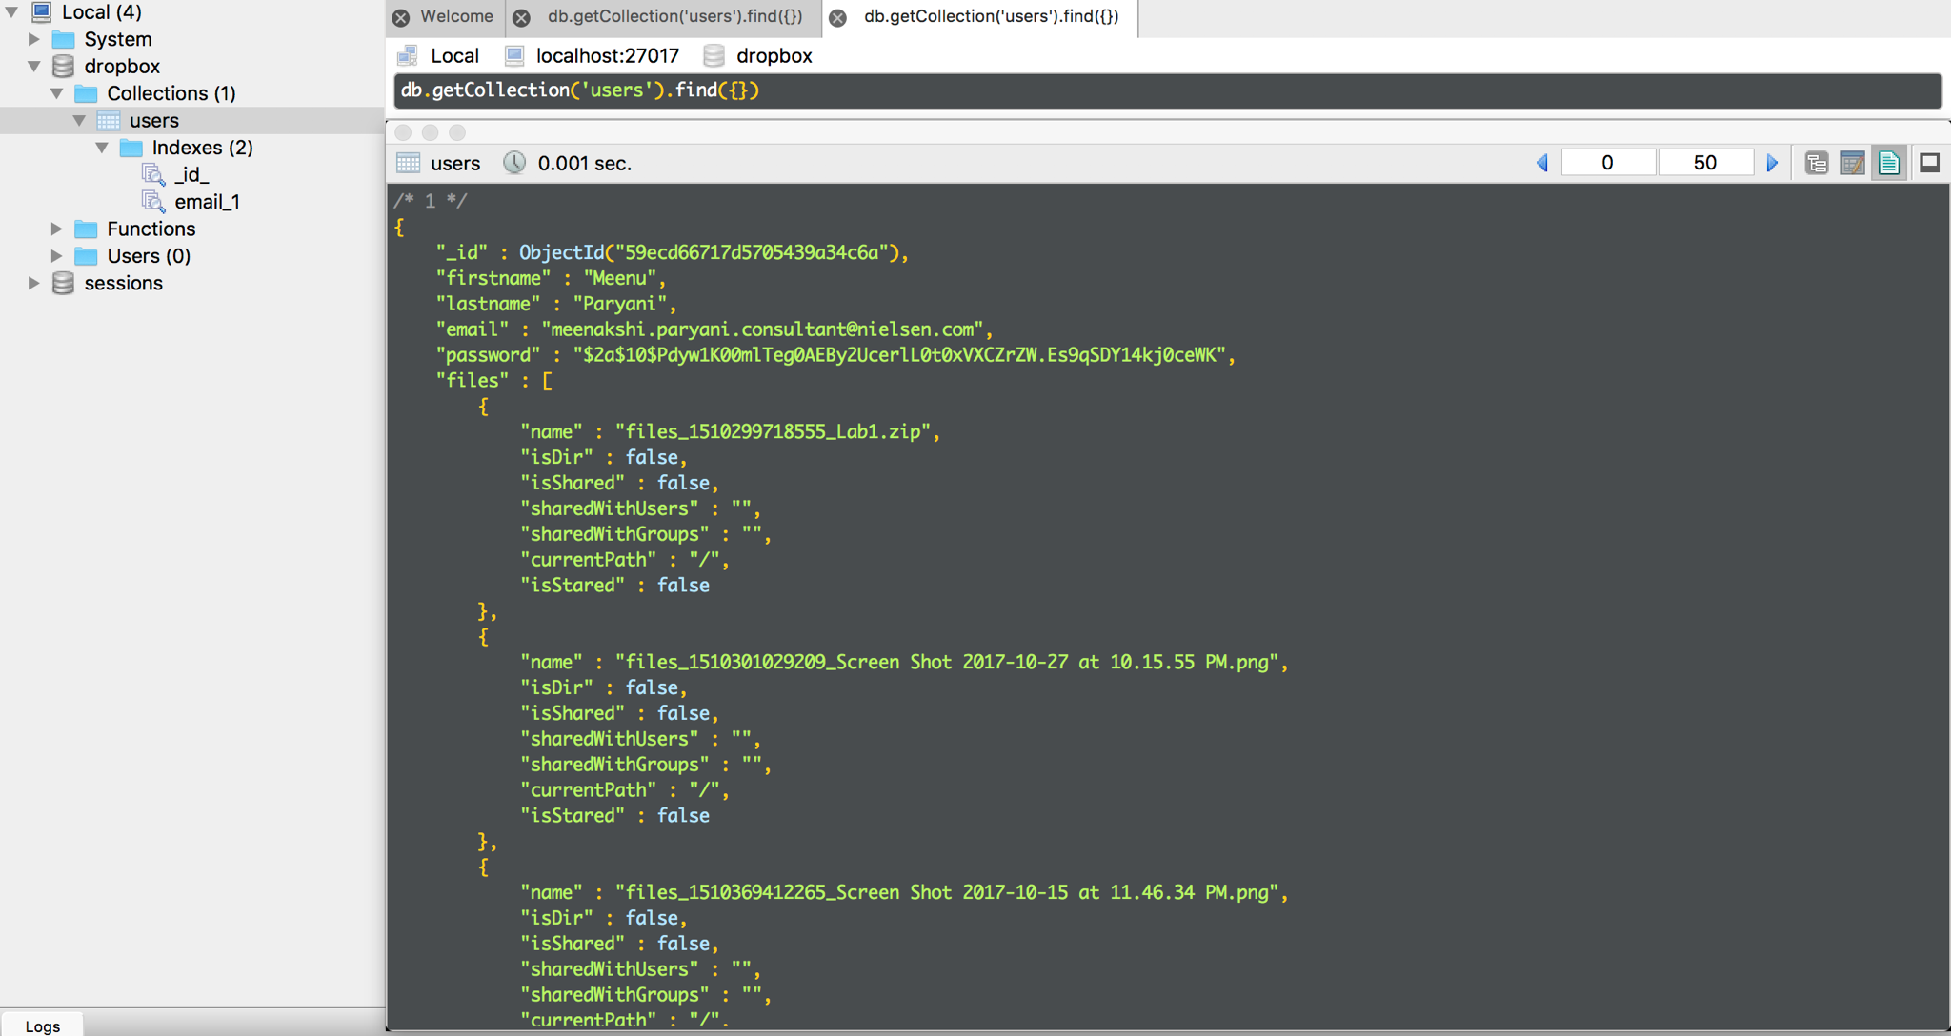

1. **Sign Out**

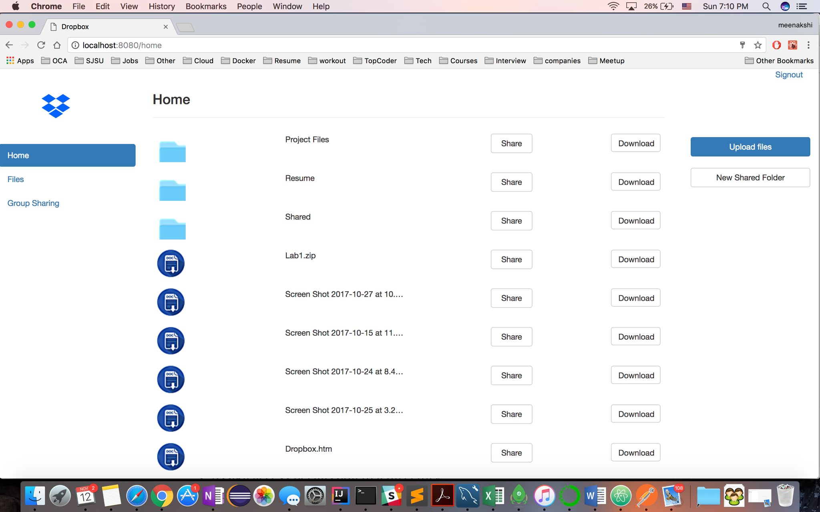

1. **Upload File**

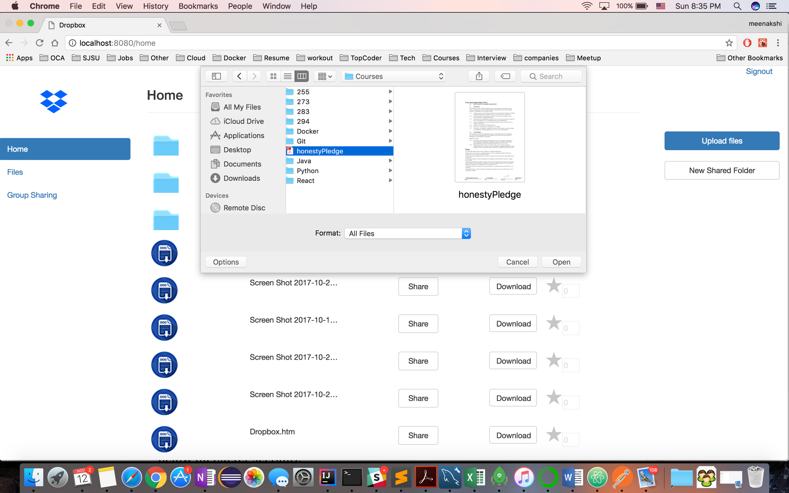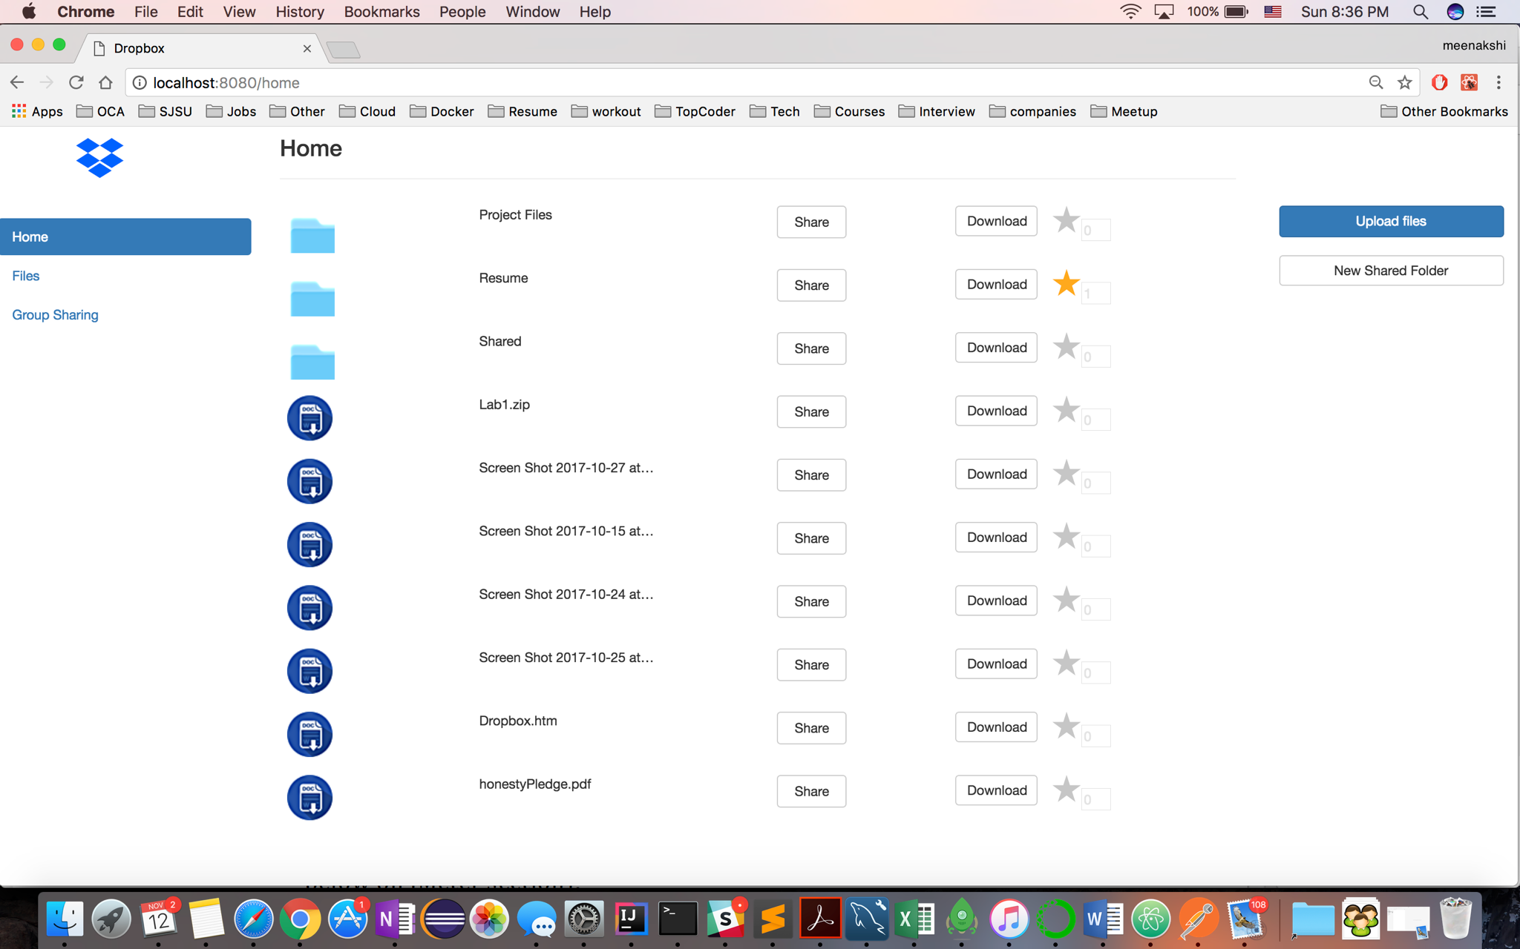

1. **List file**

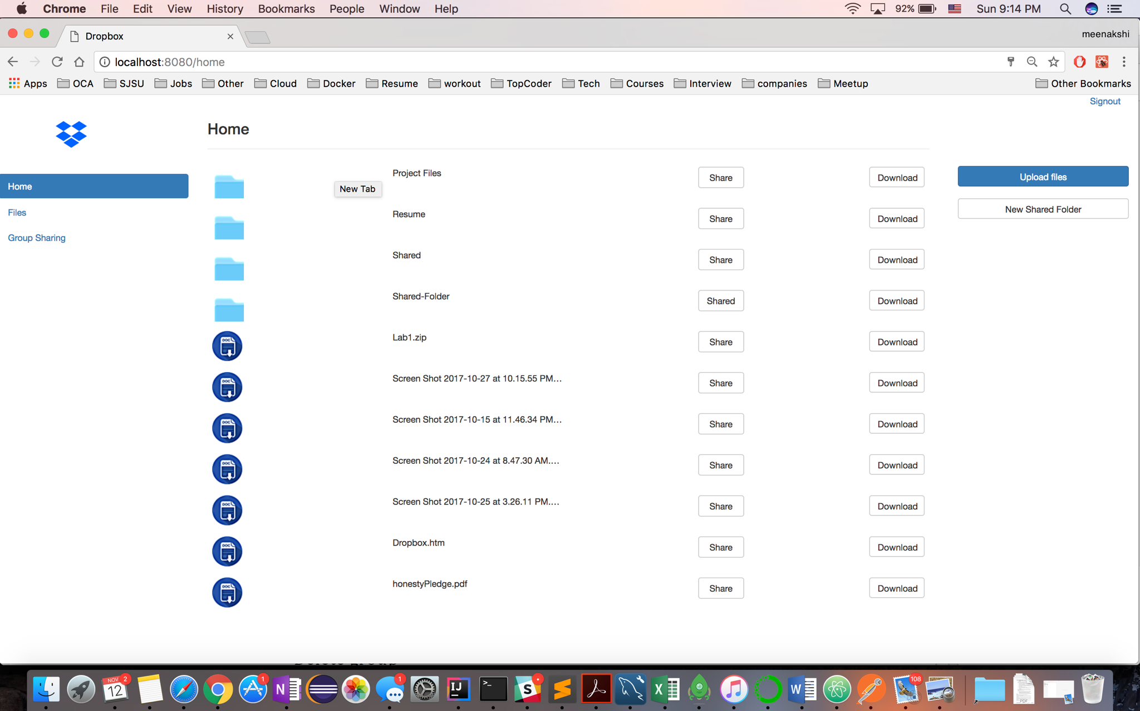

1. **Share folder/Directory by name, email, link**
2. **Share By Email/Name**

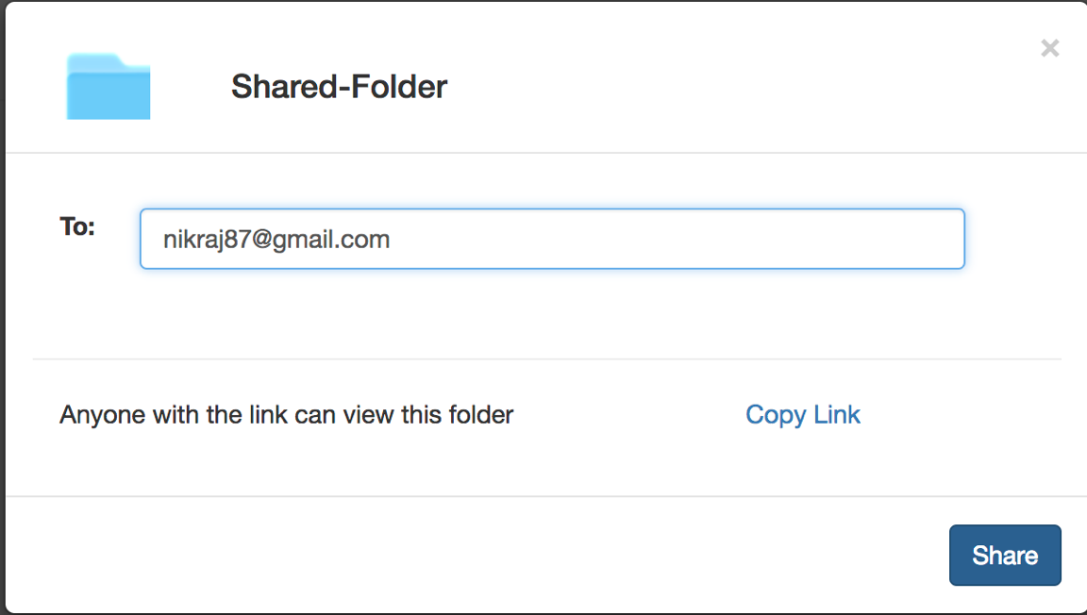

**Shared Folder appears in user’s file list**

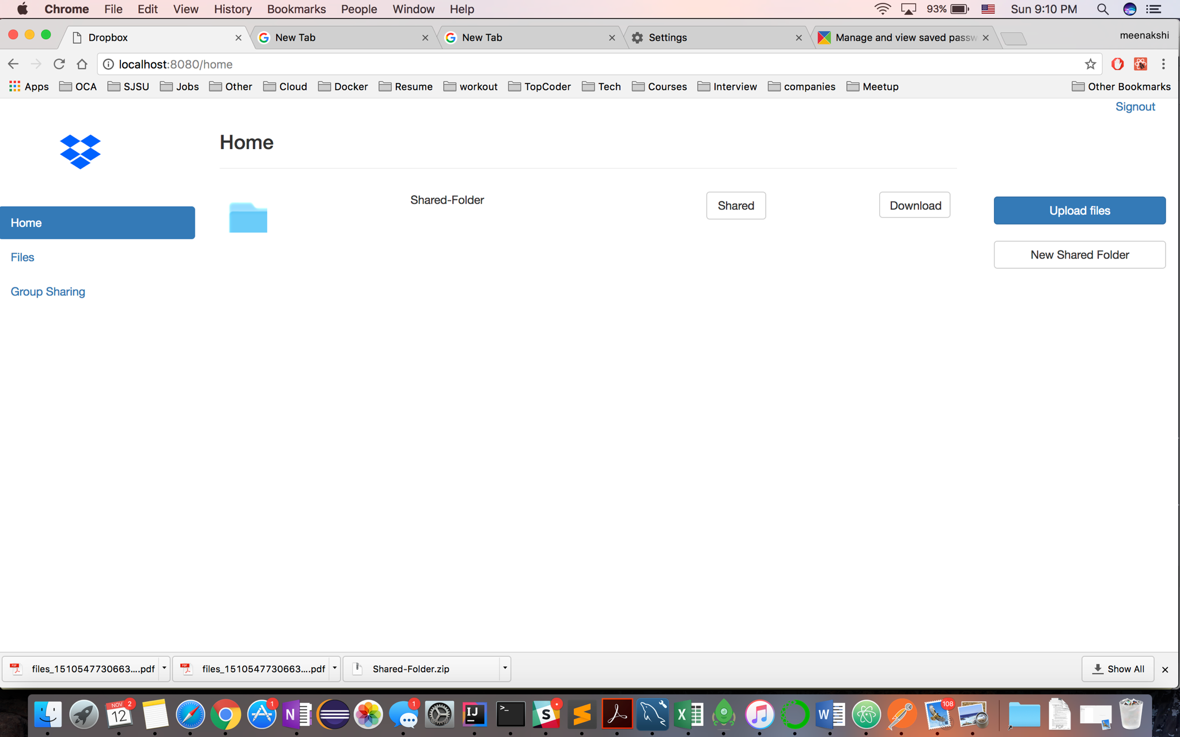

1. **Share by Link**

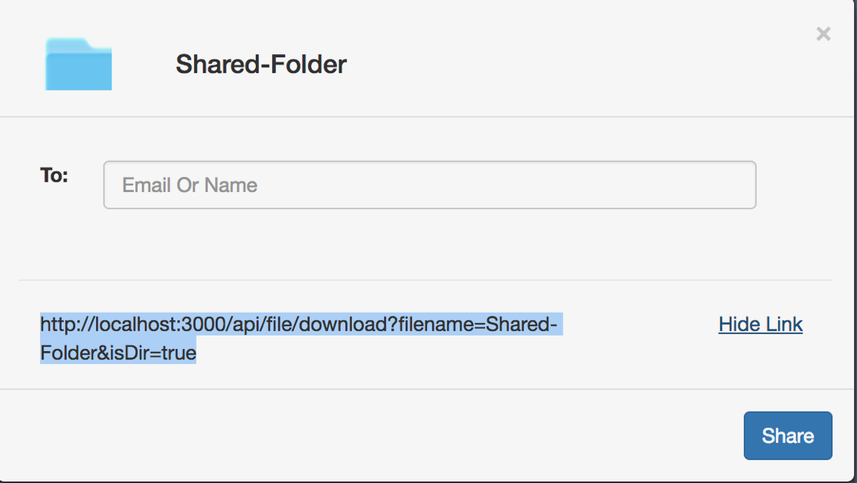

**Shared Folder downloaded as zip when accessed by link**

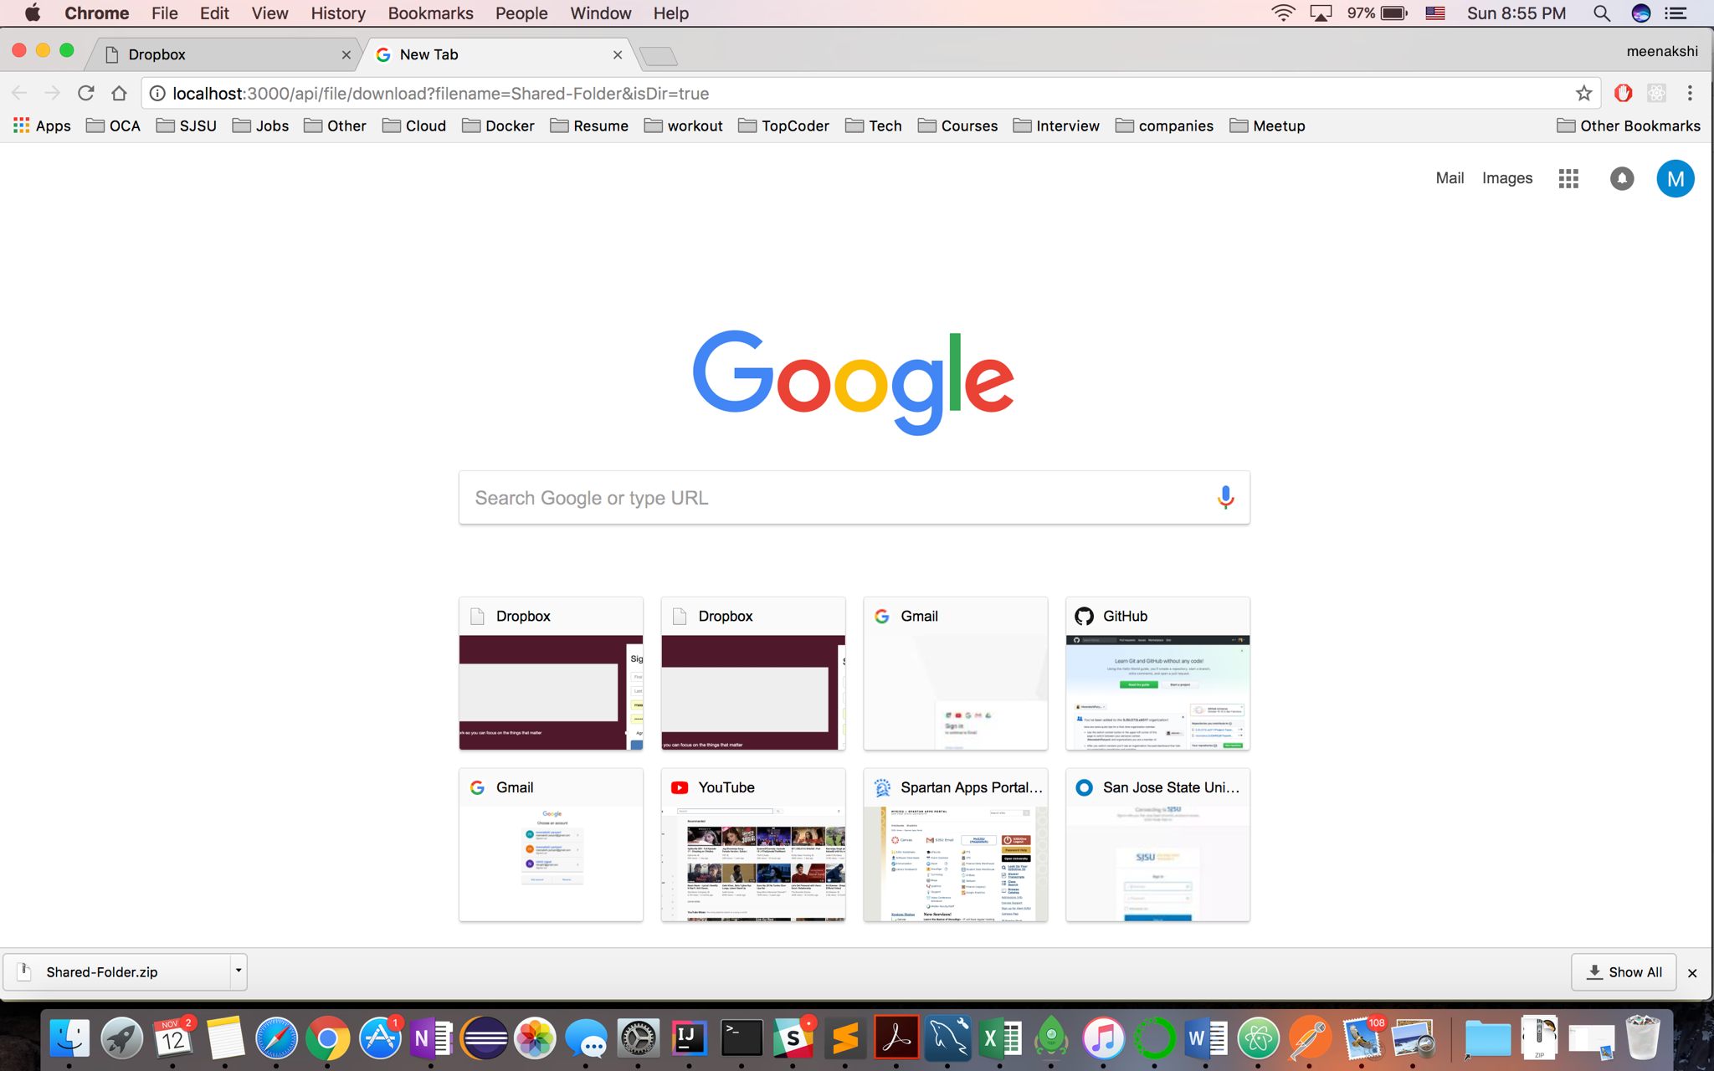

**File Downloaded in original format**

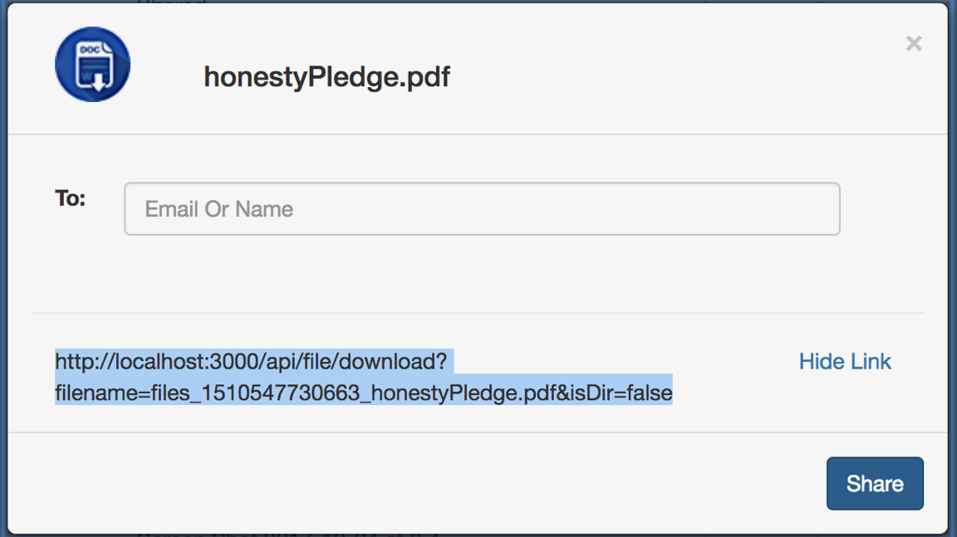

1. **Star a Directory**

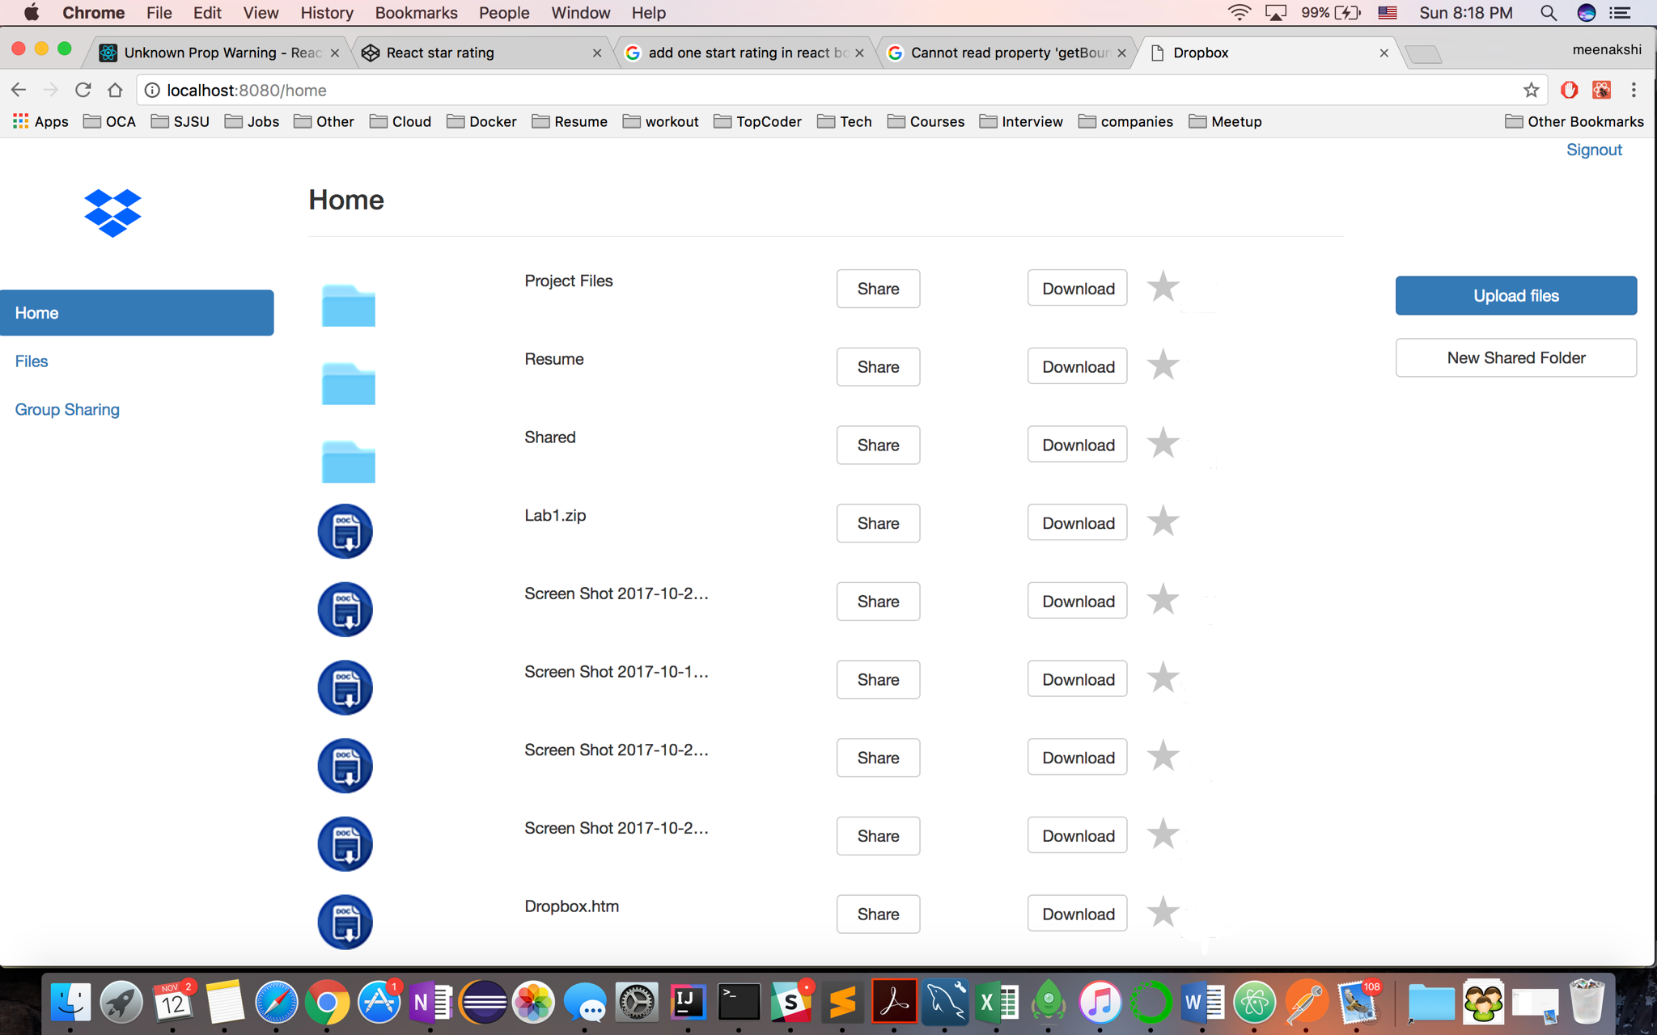

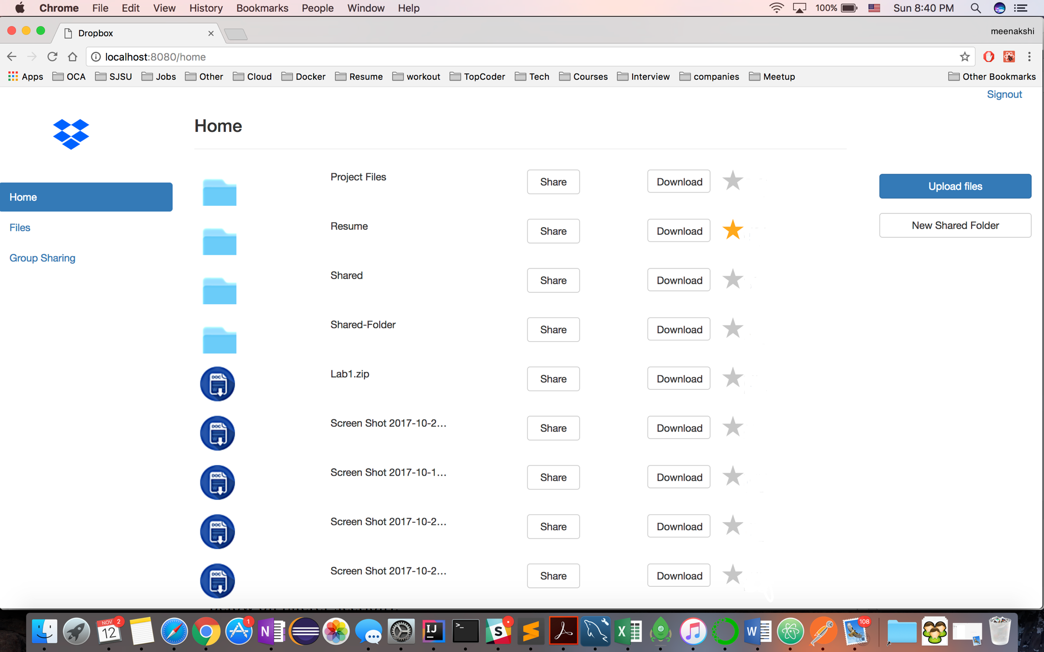

1. **Create a Directory**

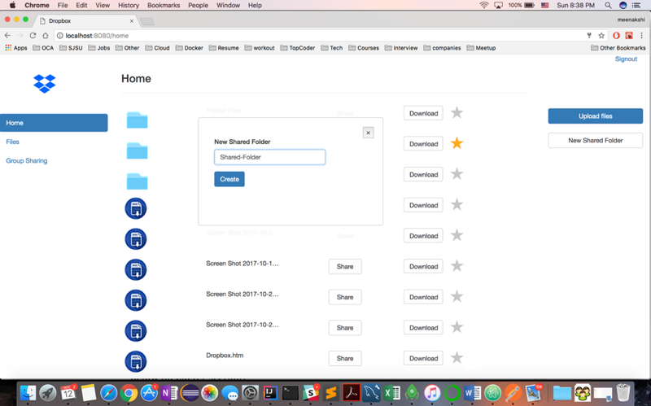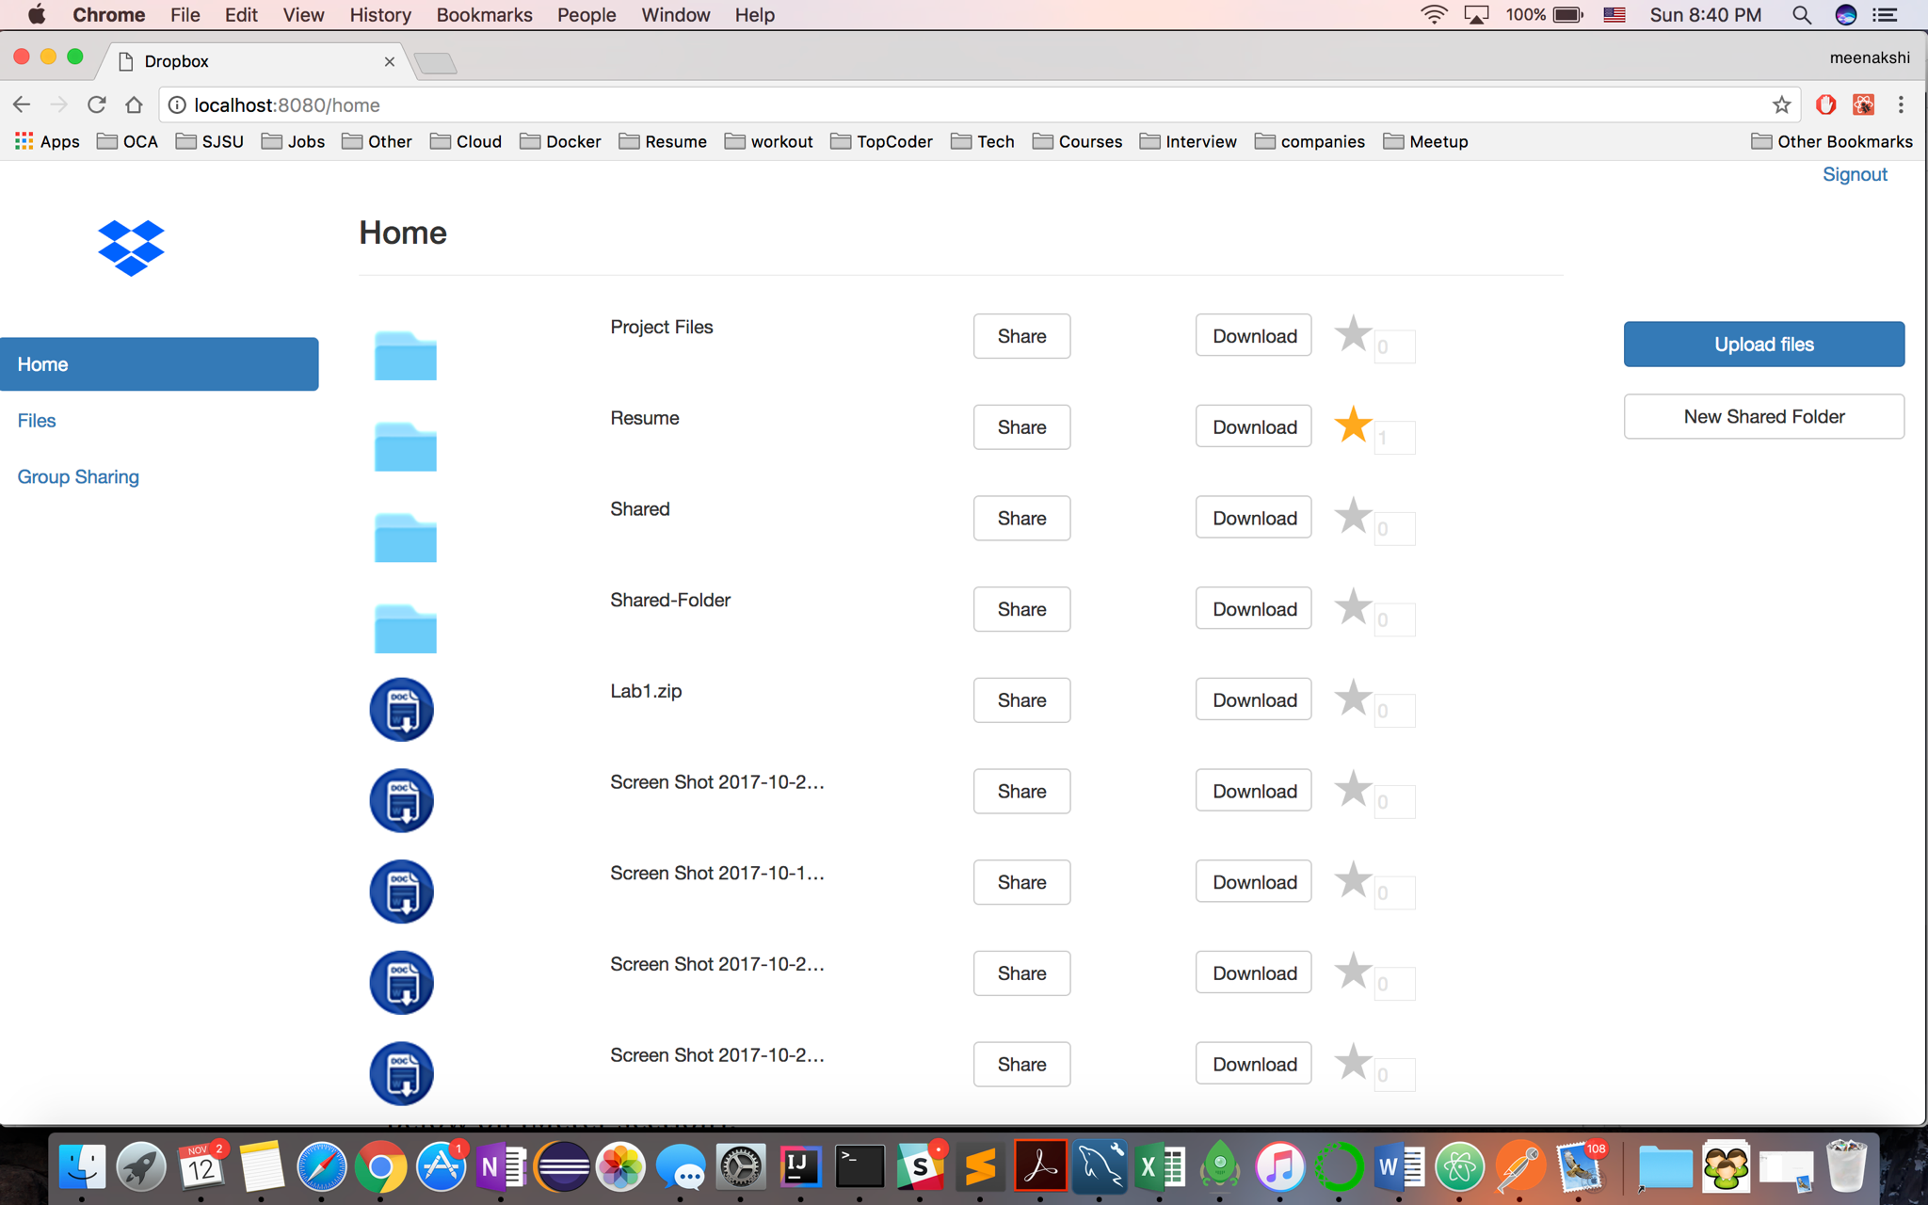

1. **Create group**

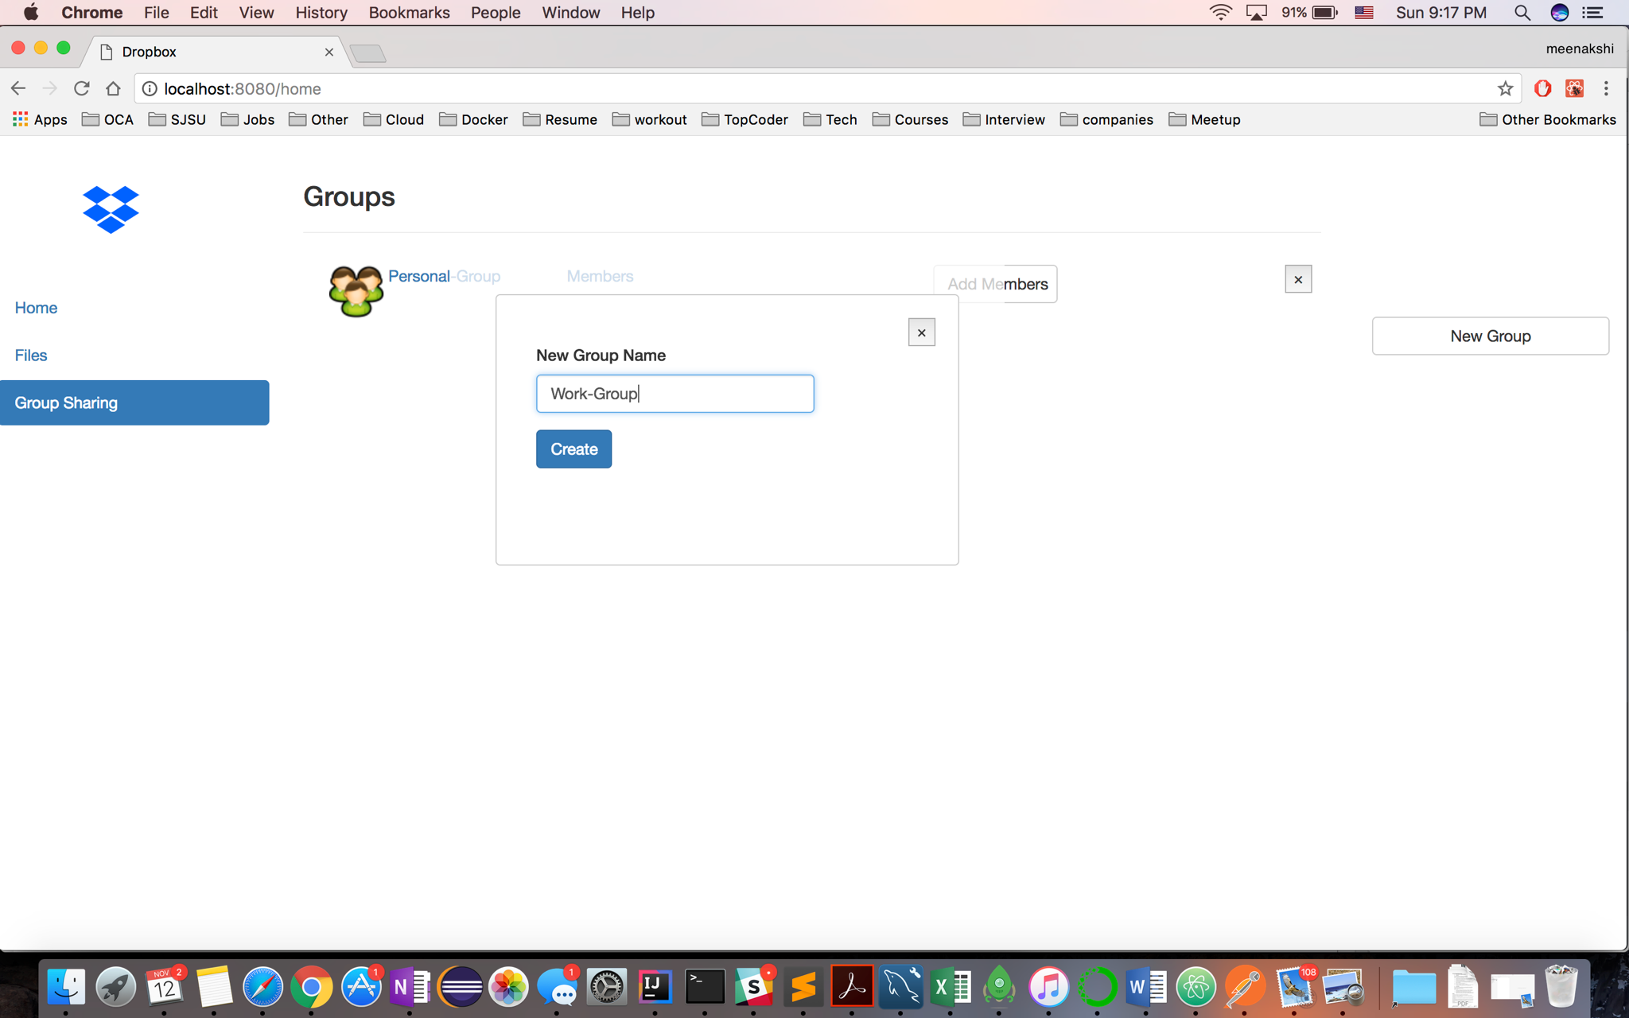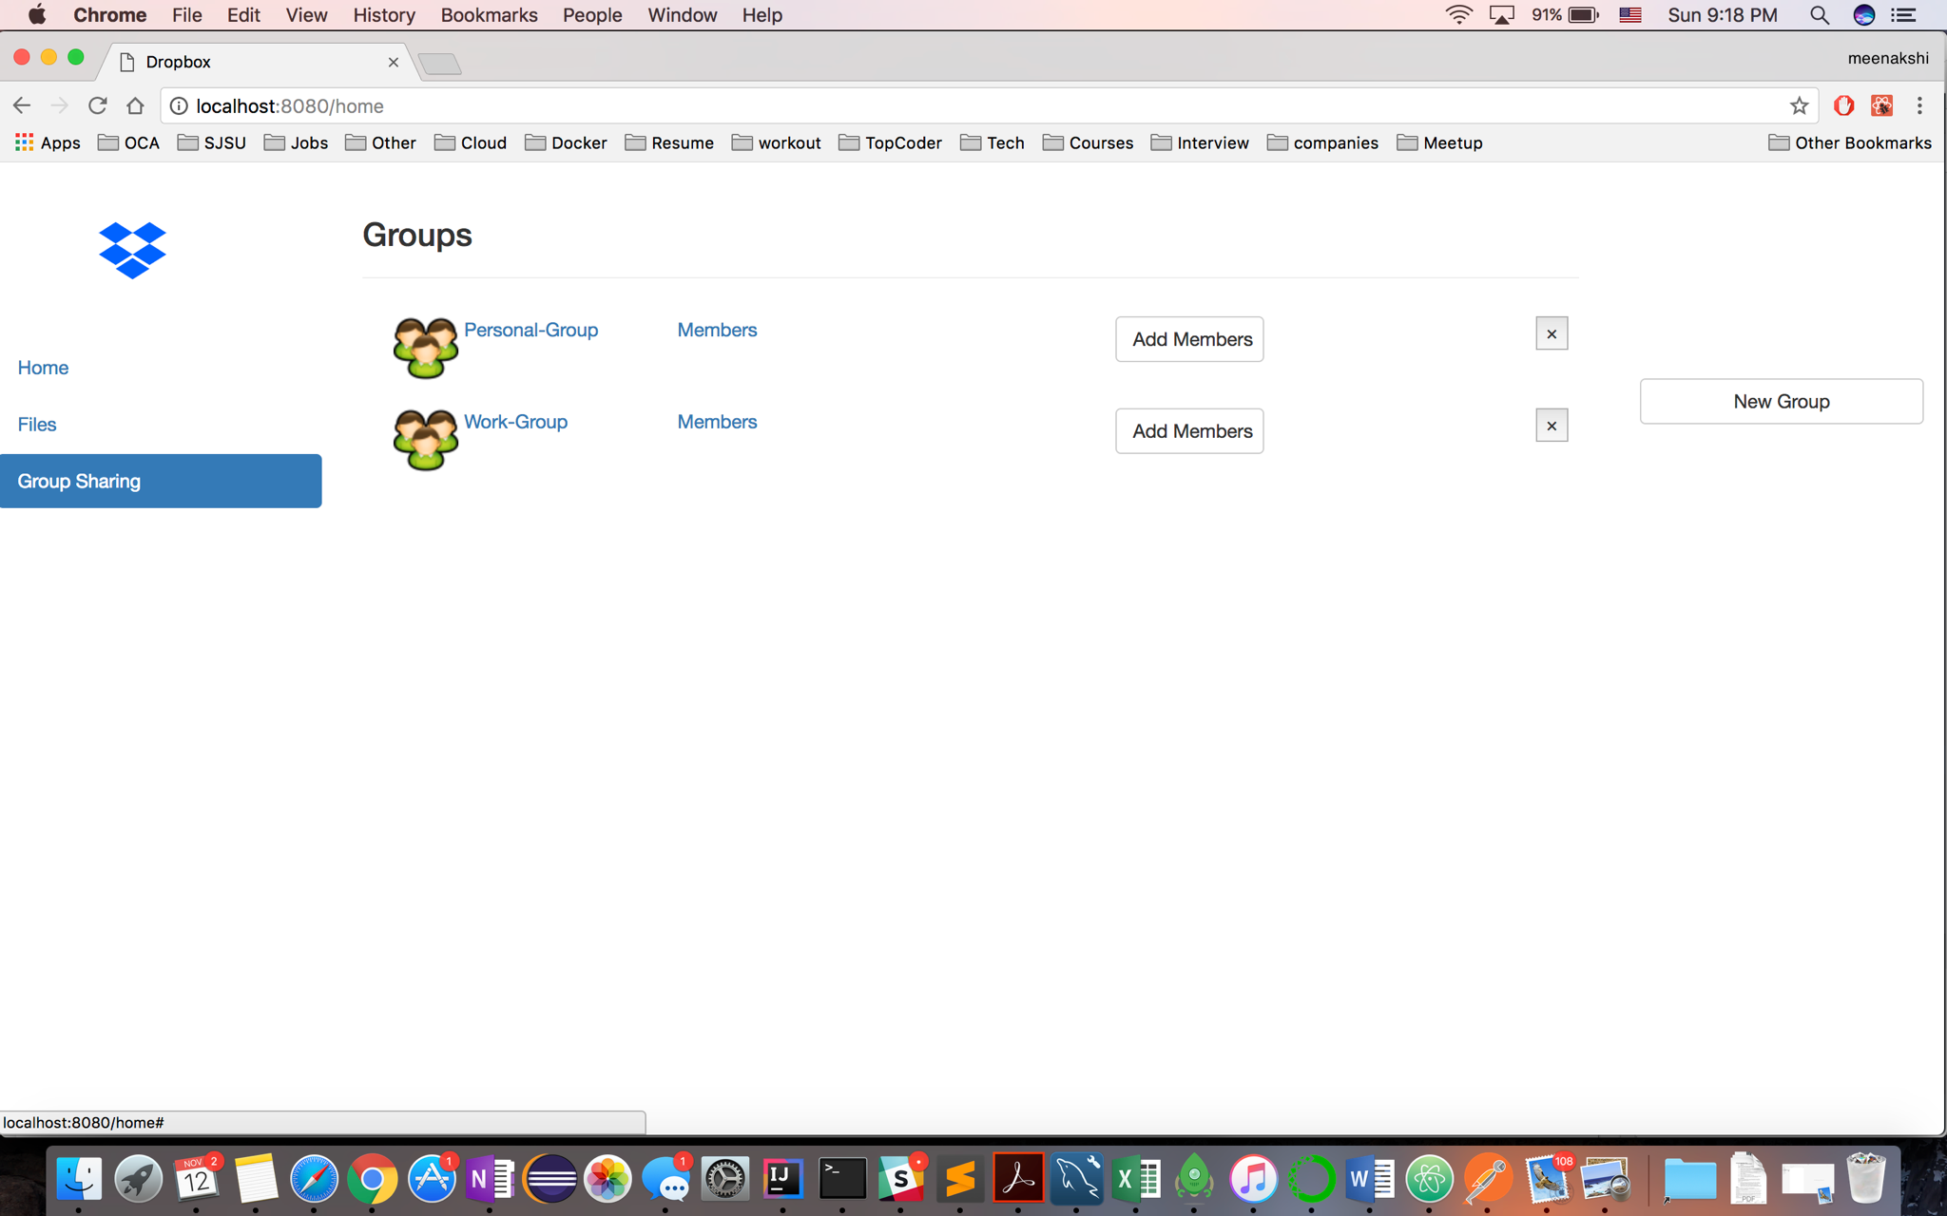

1. **Add member(s) in group**

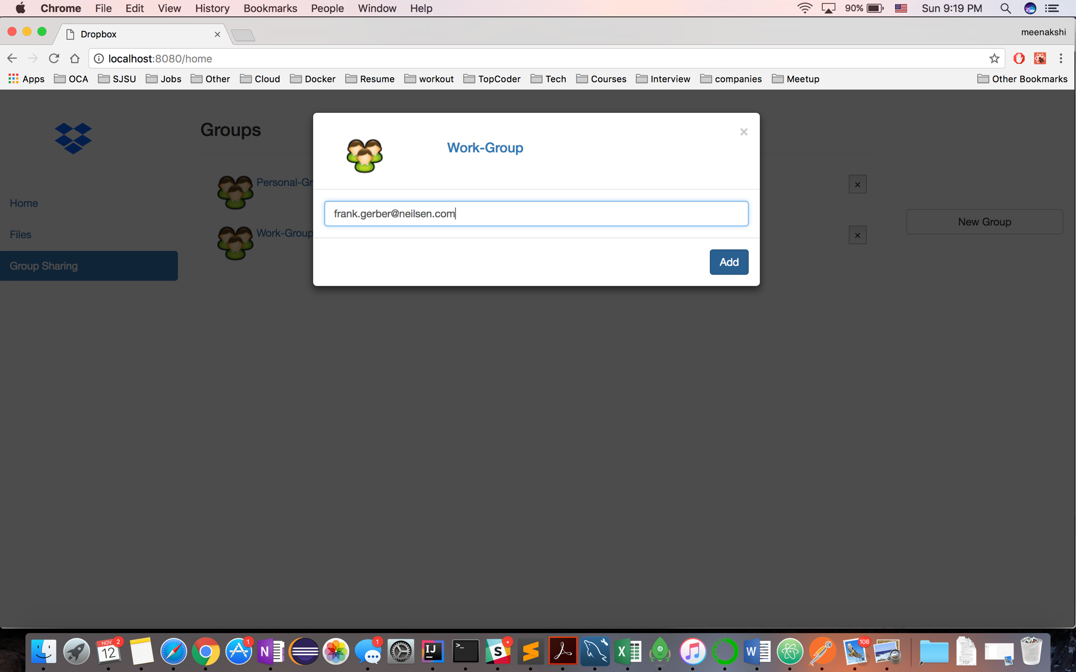

1. **Show members in group**

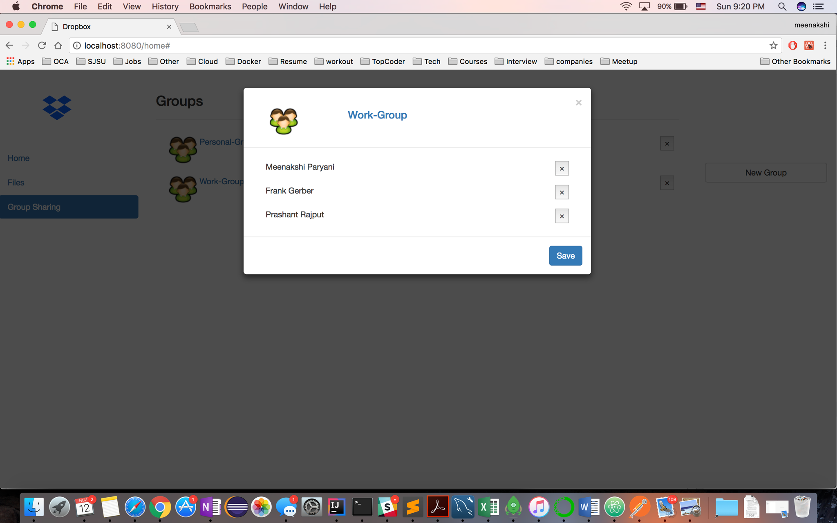

1. **Delete member from group**

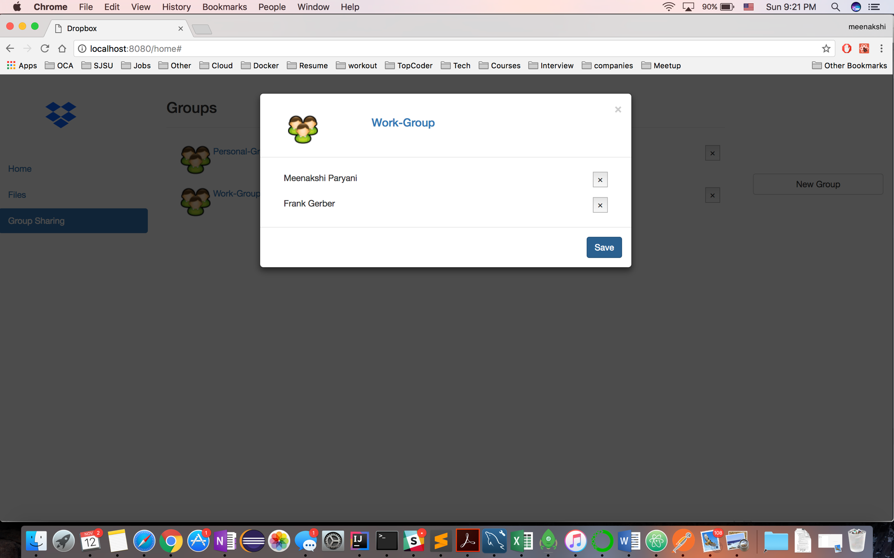

1. **Delete group**

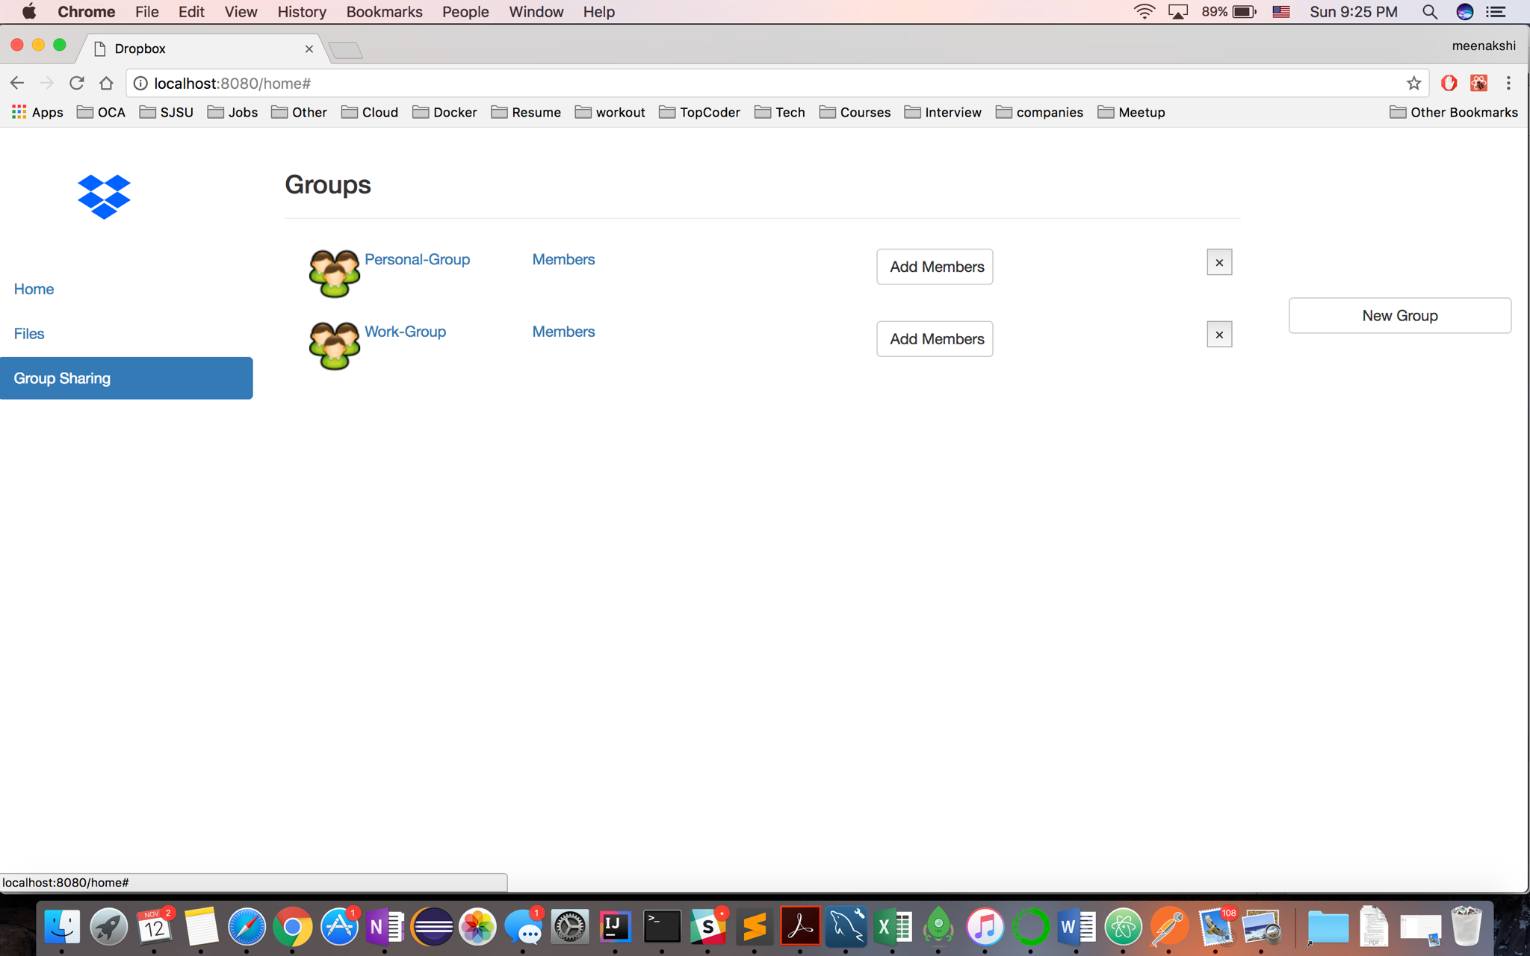

**Group Deleted**

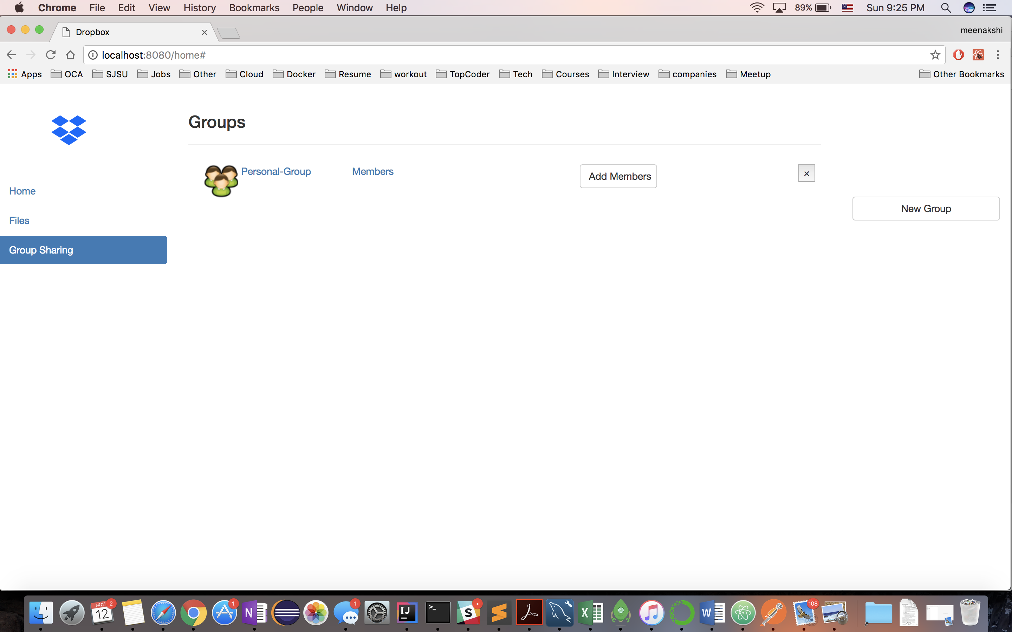

**Architecture Diagram:**

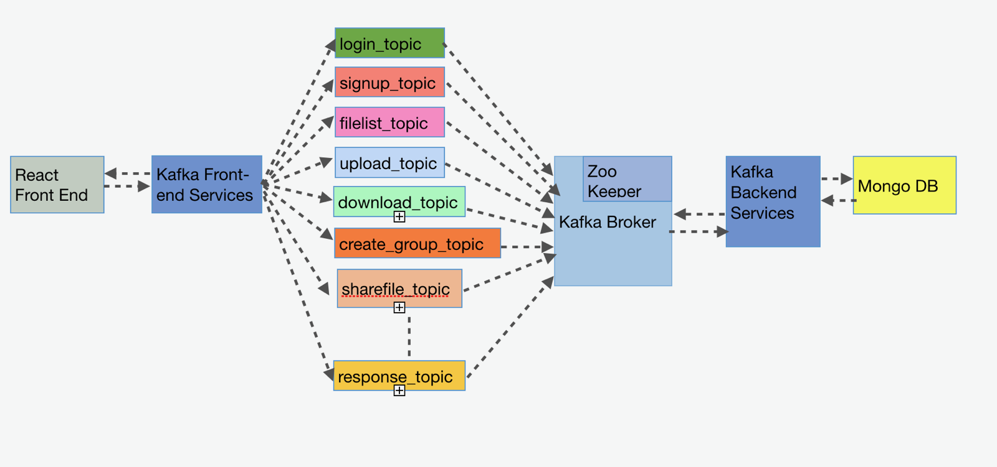

For this lab, an additional layer of Kafka services was added to improve the scalability of system. For every API service on the backend, a respective Kafka service was created with a broker in between carrying zookeeper configuration. Each service was allocated one request topic which would be used for dumping the API request and one response queue was created for all the API services to respond to the Kafka frontend services. The database used for this lab is MongoDB.

User authentication, session management, file storage, group storage etc was stored in a single MongoDB collection for faster and easier access. The connection pooling was implemented instead of using MongoDB provided connection pooling. Performance of the system was noted for both – with and without the connection pooling implemented. The database was configured to have 1000 connections at a time.

**Q.1 - Compare passport authentication process with the authentication process used in Lab1**

In Lab 1, a simple authentication mechanism was used in which there was no encryption of the passwords. In Lab2, passport authentication was used with local strategy and internal algorithm for encrypting the passwords, thereby providing higher security standards, so now when user tries to login to the system, he doesn’t have to remember the password everytime. The browser storage automatically stores the user credentials. Also, the express session management was used due to which user would be routed to the home page instead of the login page till the time session is valid since the session information is stored in MongoDB as part of the passport authentication. With every API request, a user session cookie was passed along with the request to identify it as authorized or unauthorized access due to which it became simple to check the authenticity of the user for every incoming request.

**Q.2 – Compare performance with and without Kafka. Explain in detail the reason for difference in performance**

**JMeter Results with Kafka Services:**

**100 Concurrent Users**:

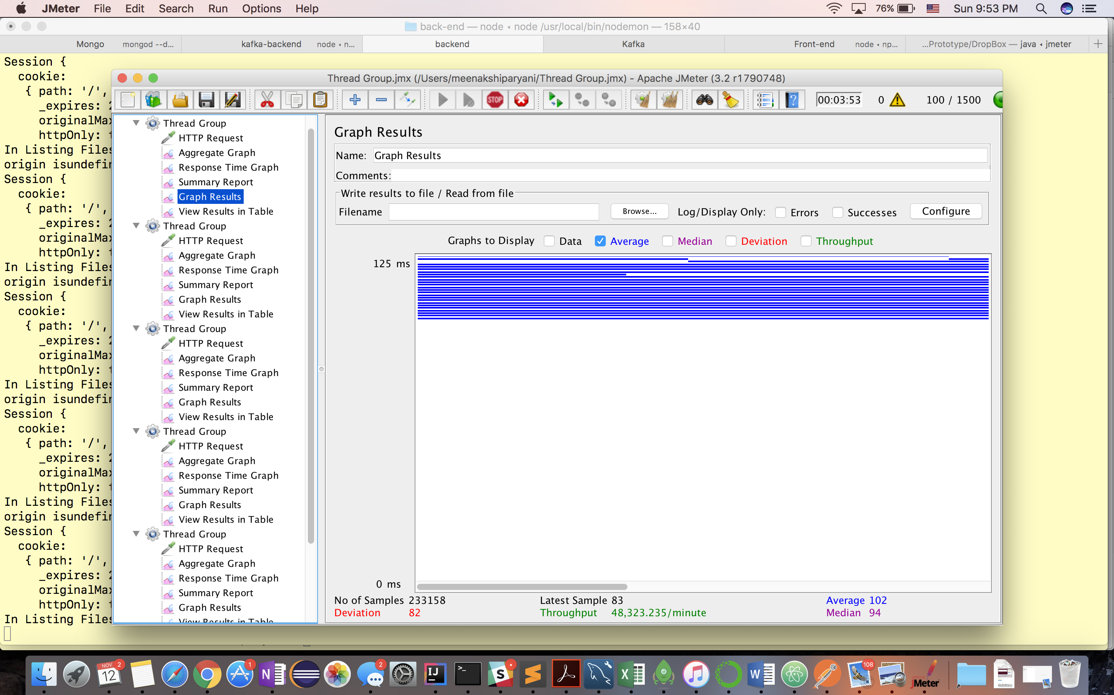

**200 Concurrent Users:**

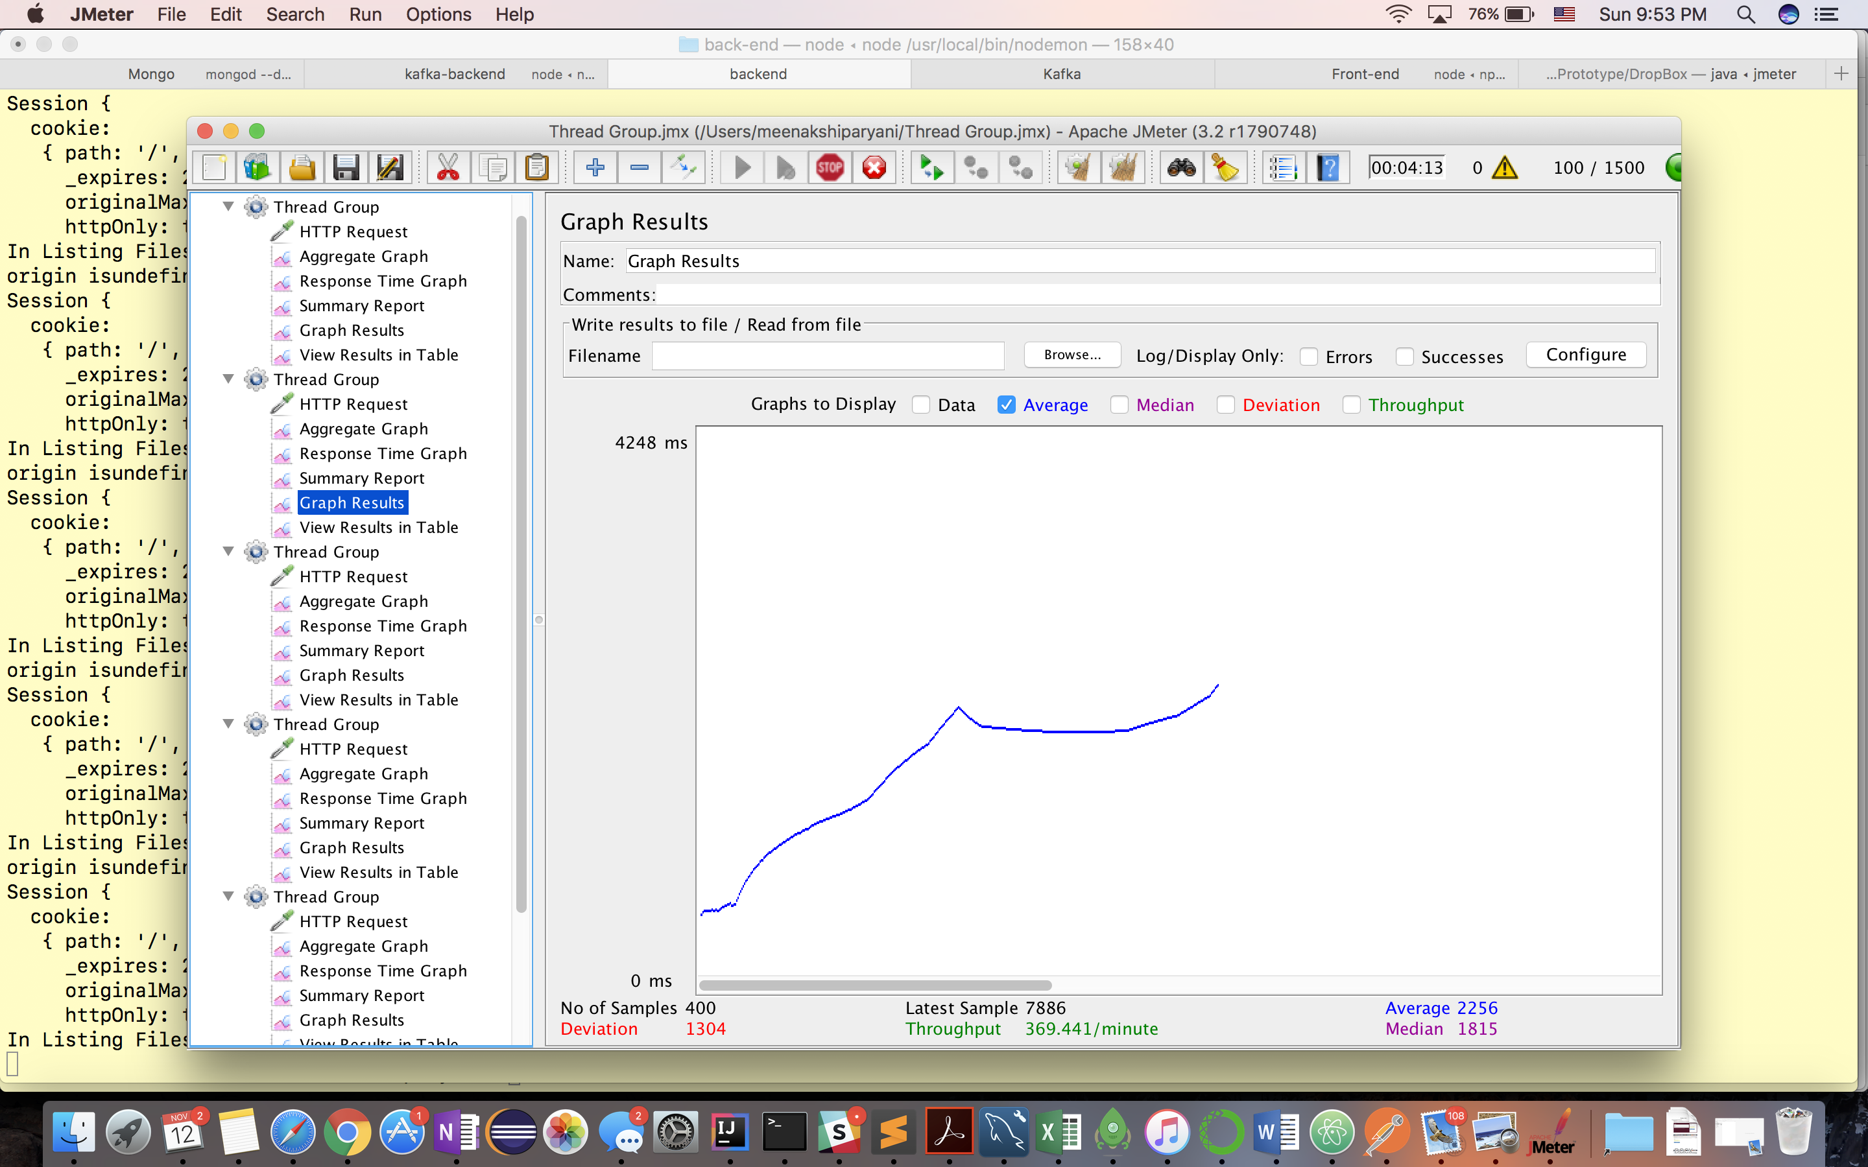

**300 Concurrent Users:** 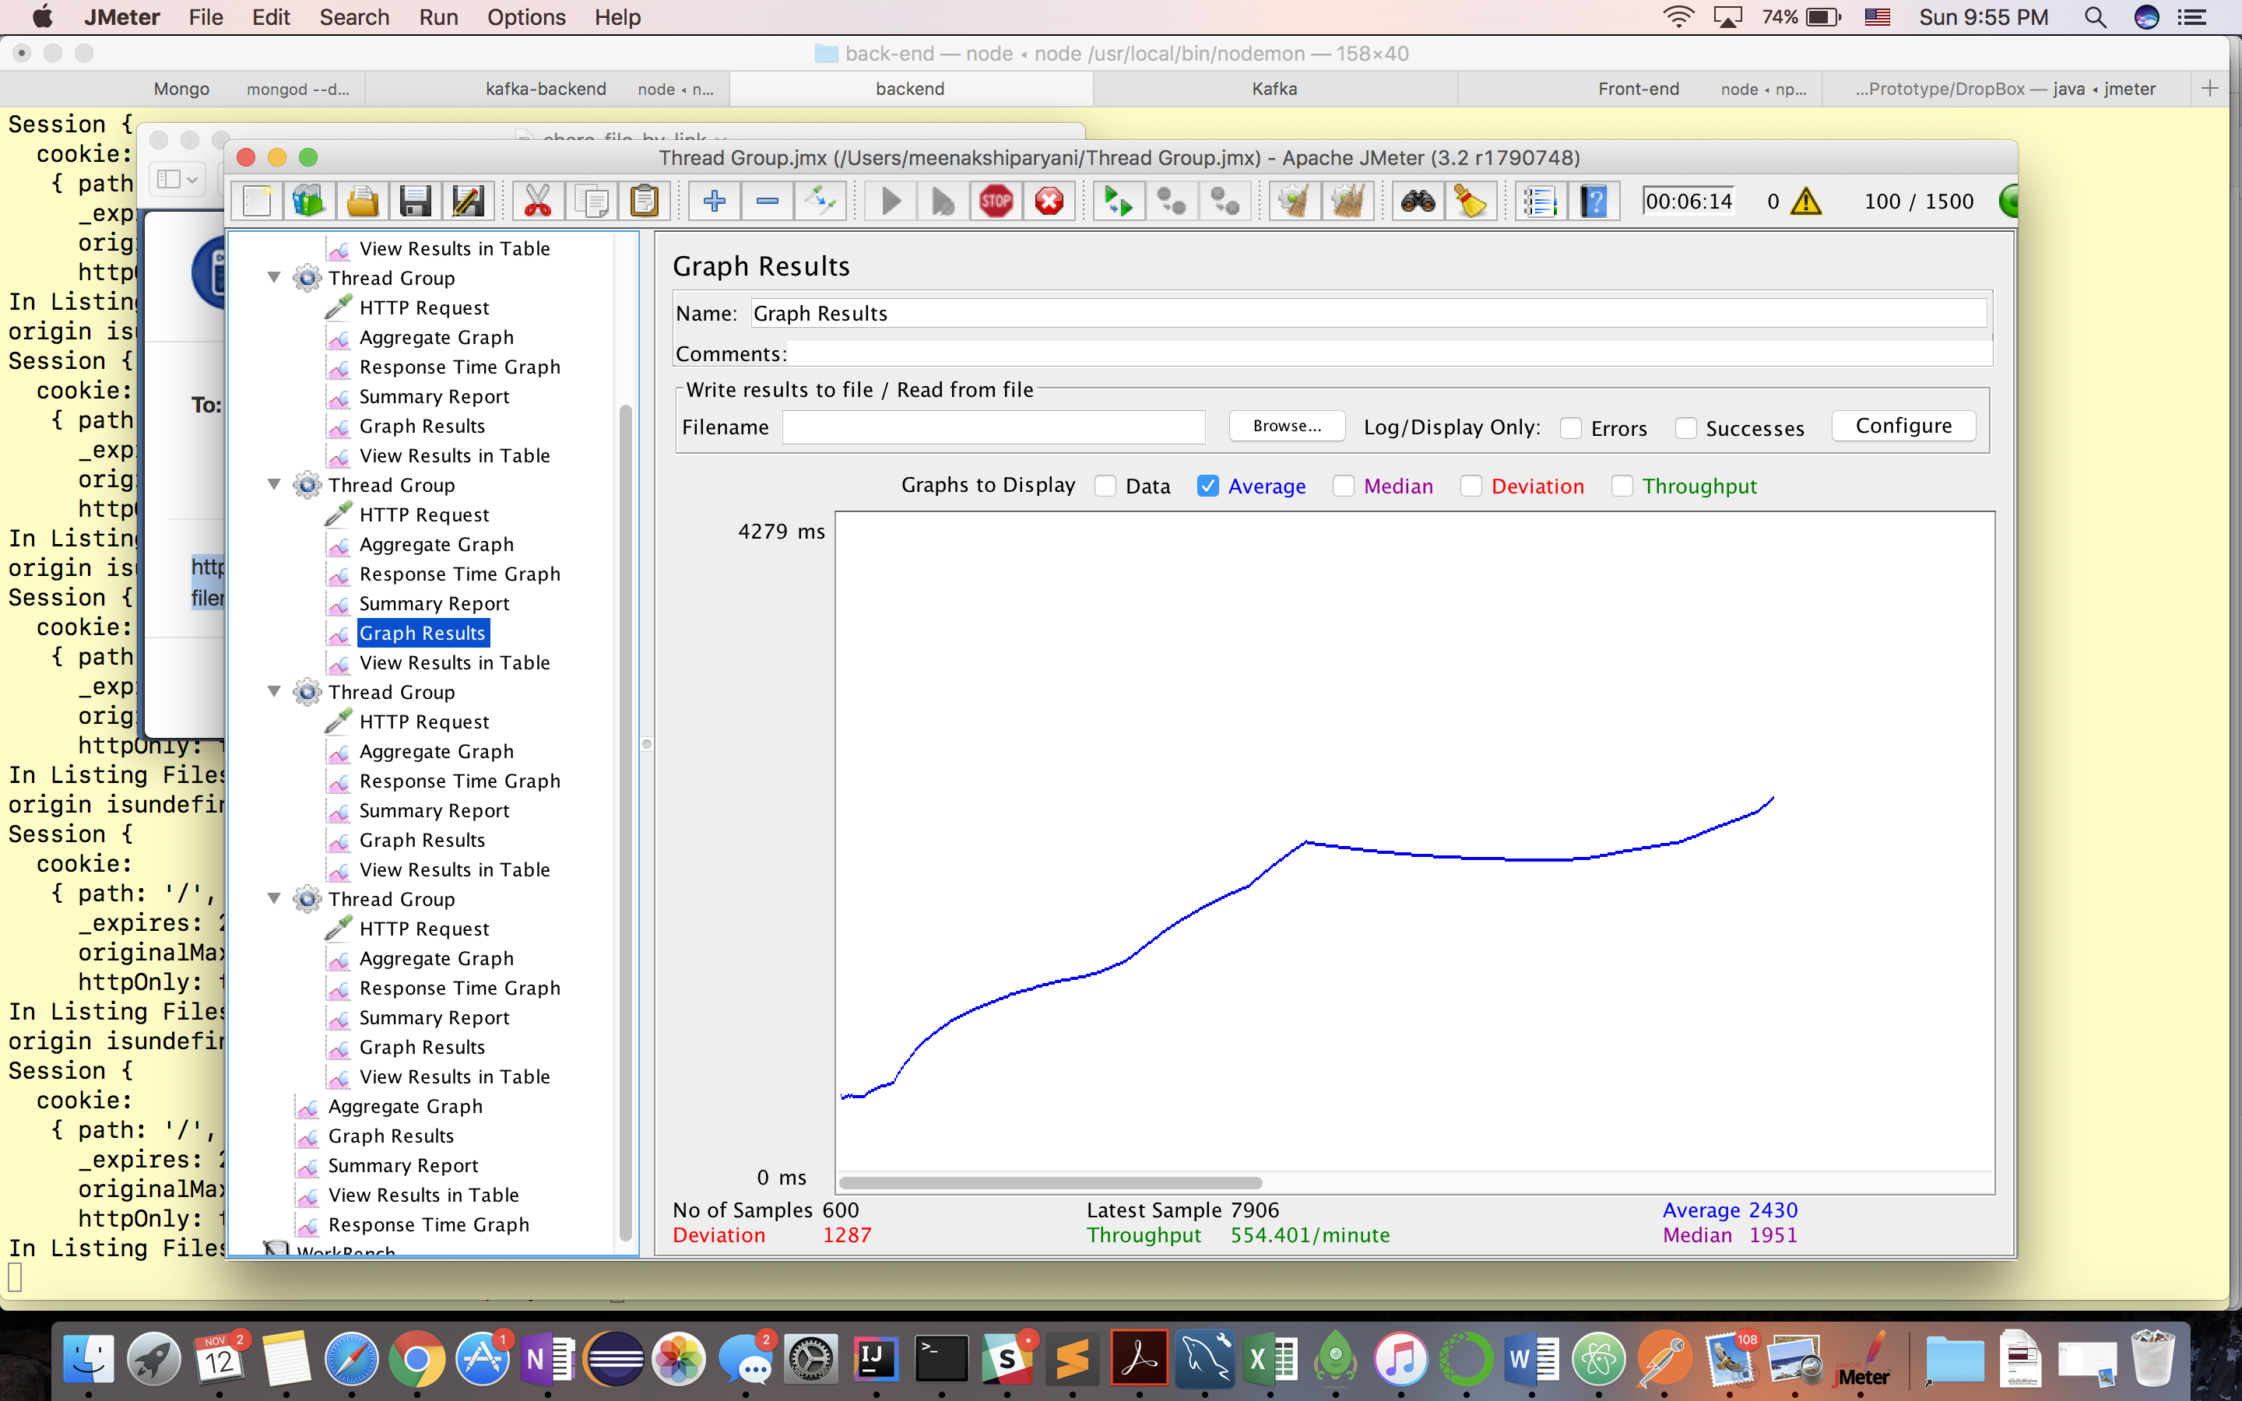

**400 Concurrent Users:**

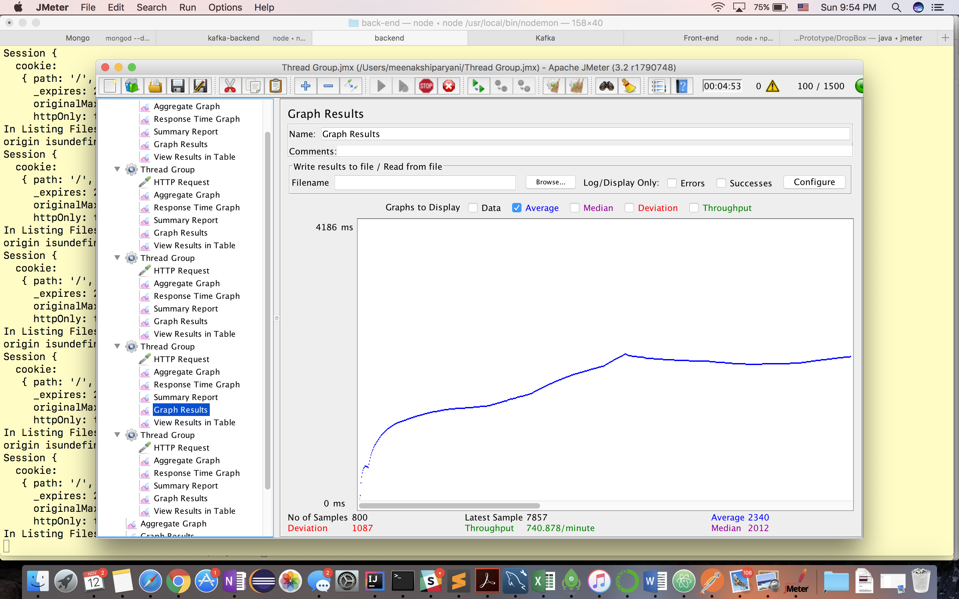

**500 Concurrent Users:**

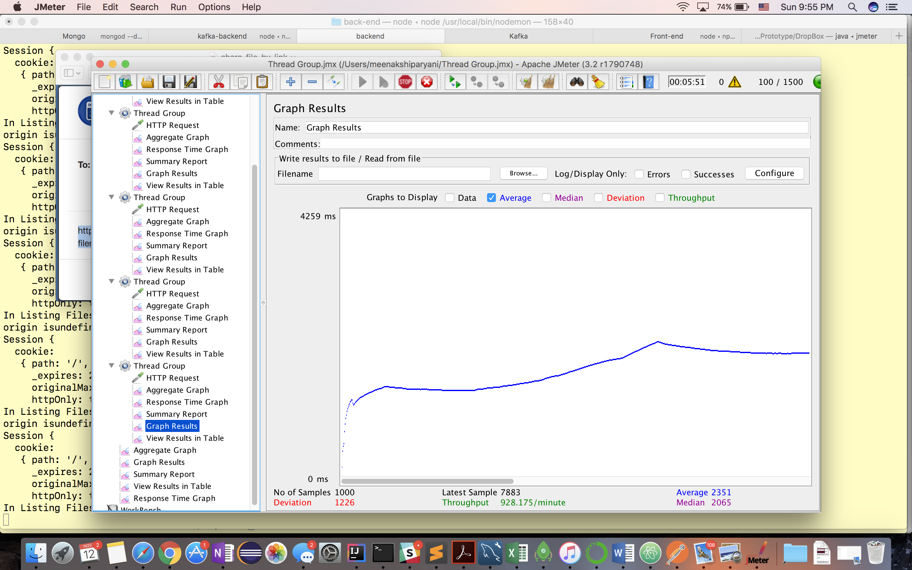

**Average Response Time**

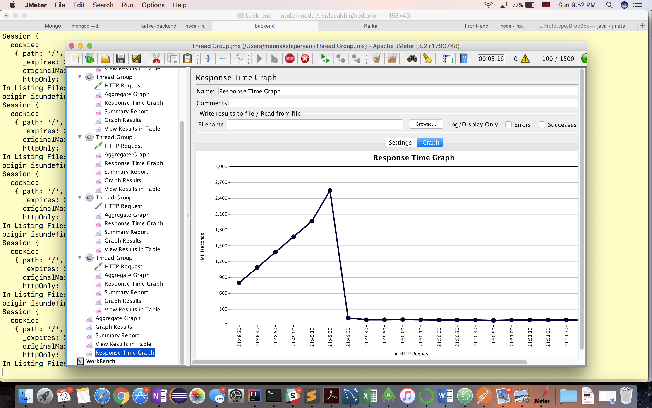

**Without Kafka Services**:

**100 Concurrent Users:**

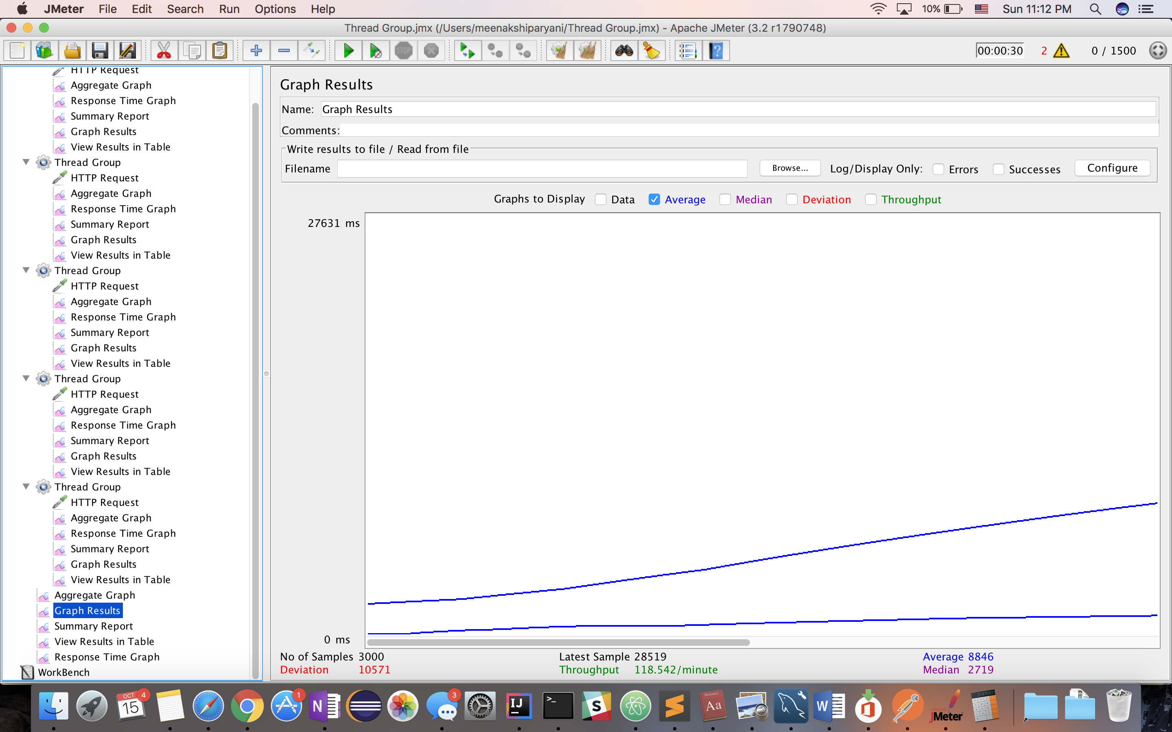

**200 Concurrent Users:**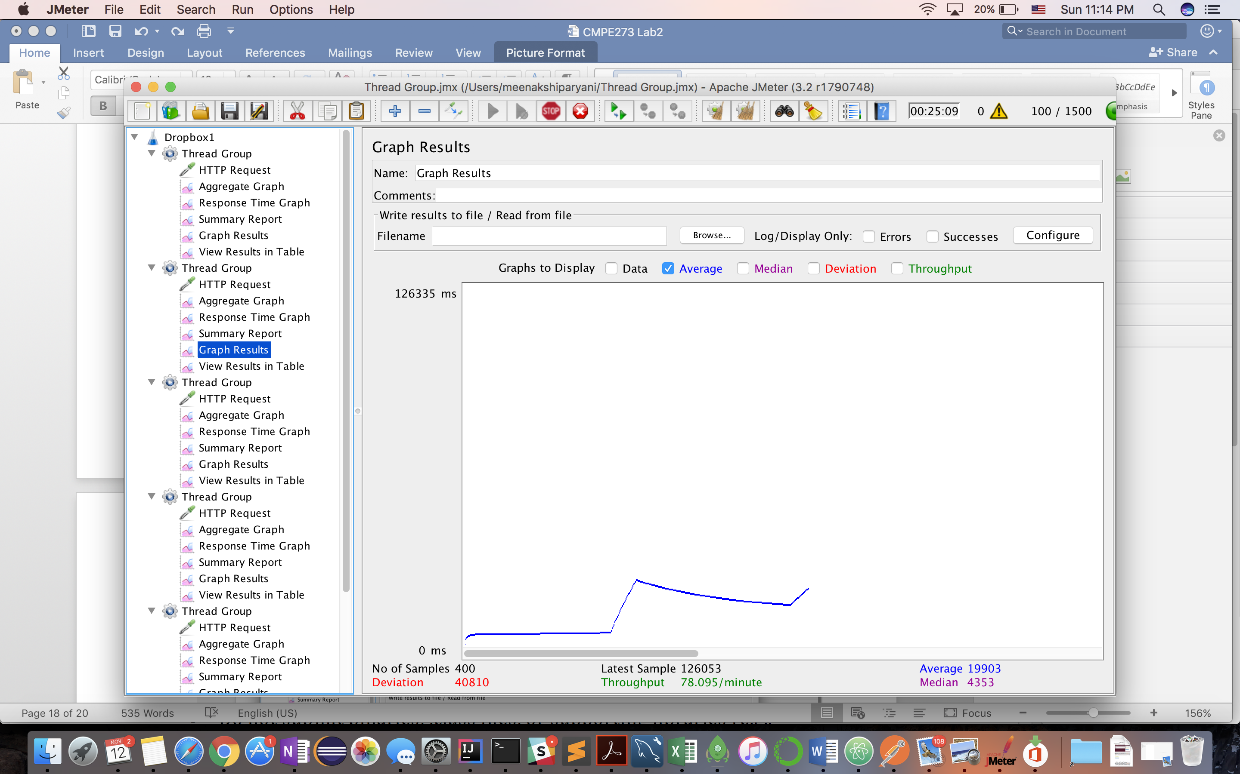

**300 Concurrent Users:**

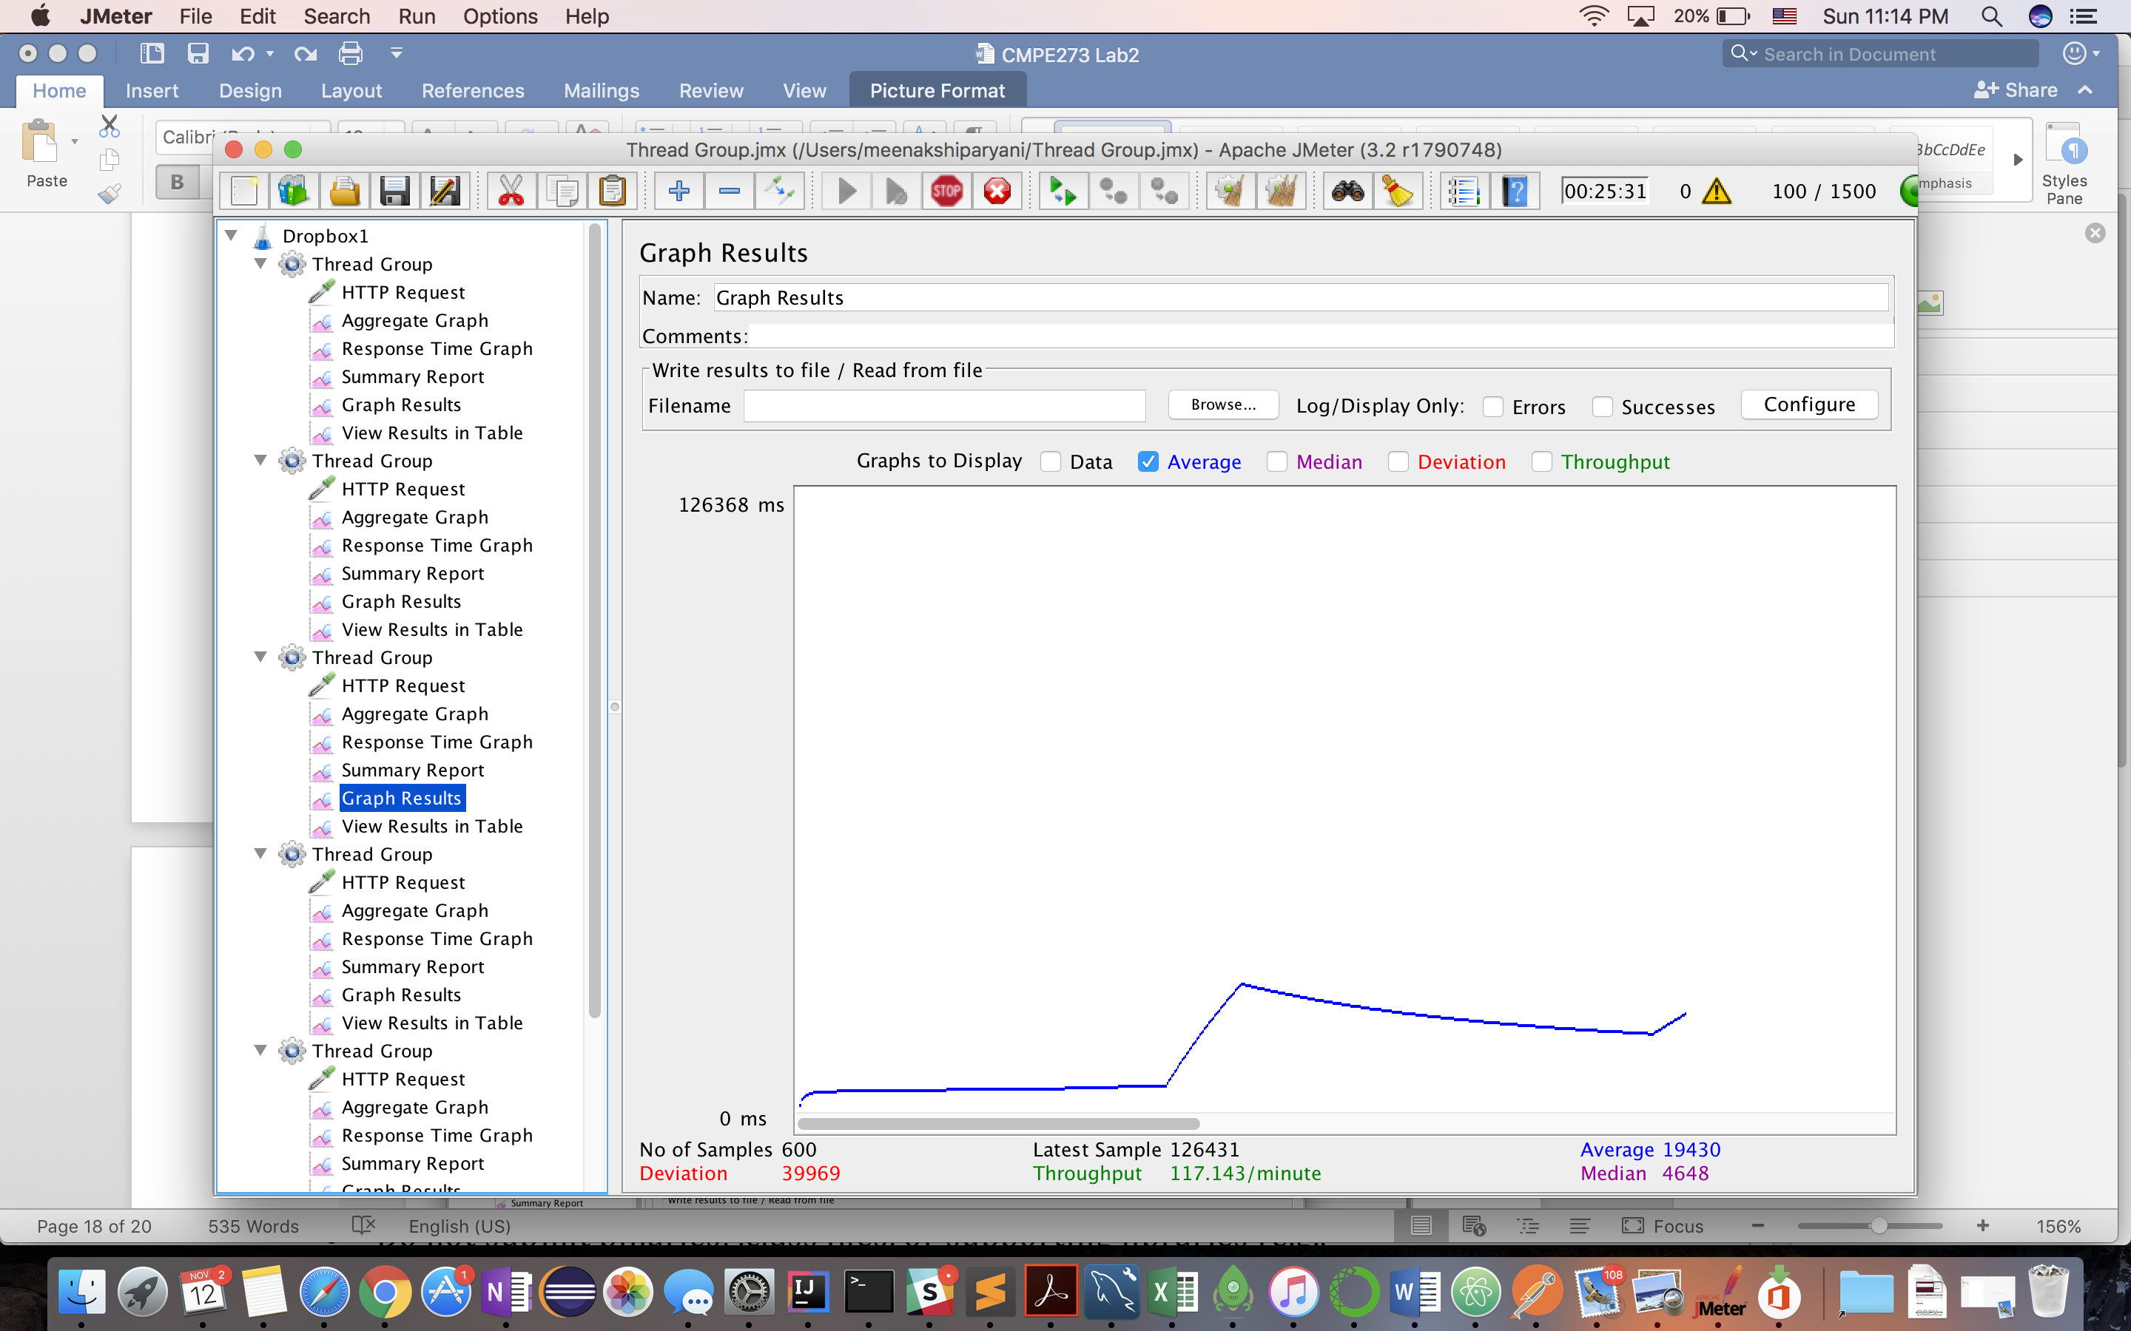

**400 Concurrent Users:**

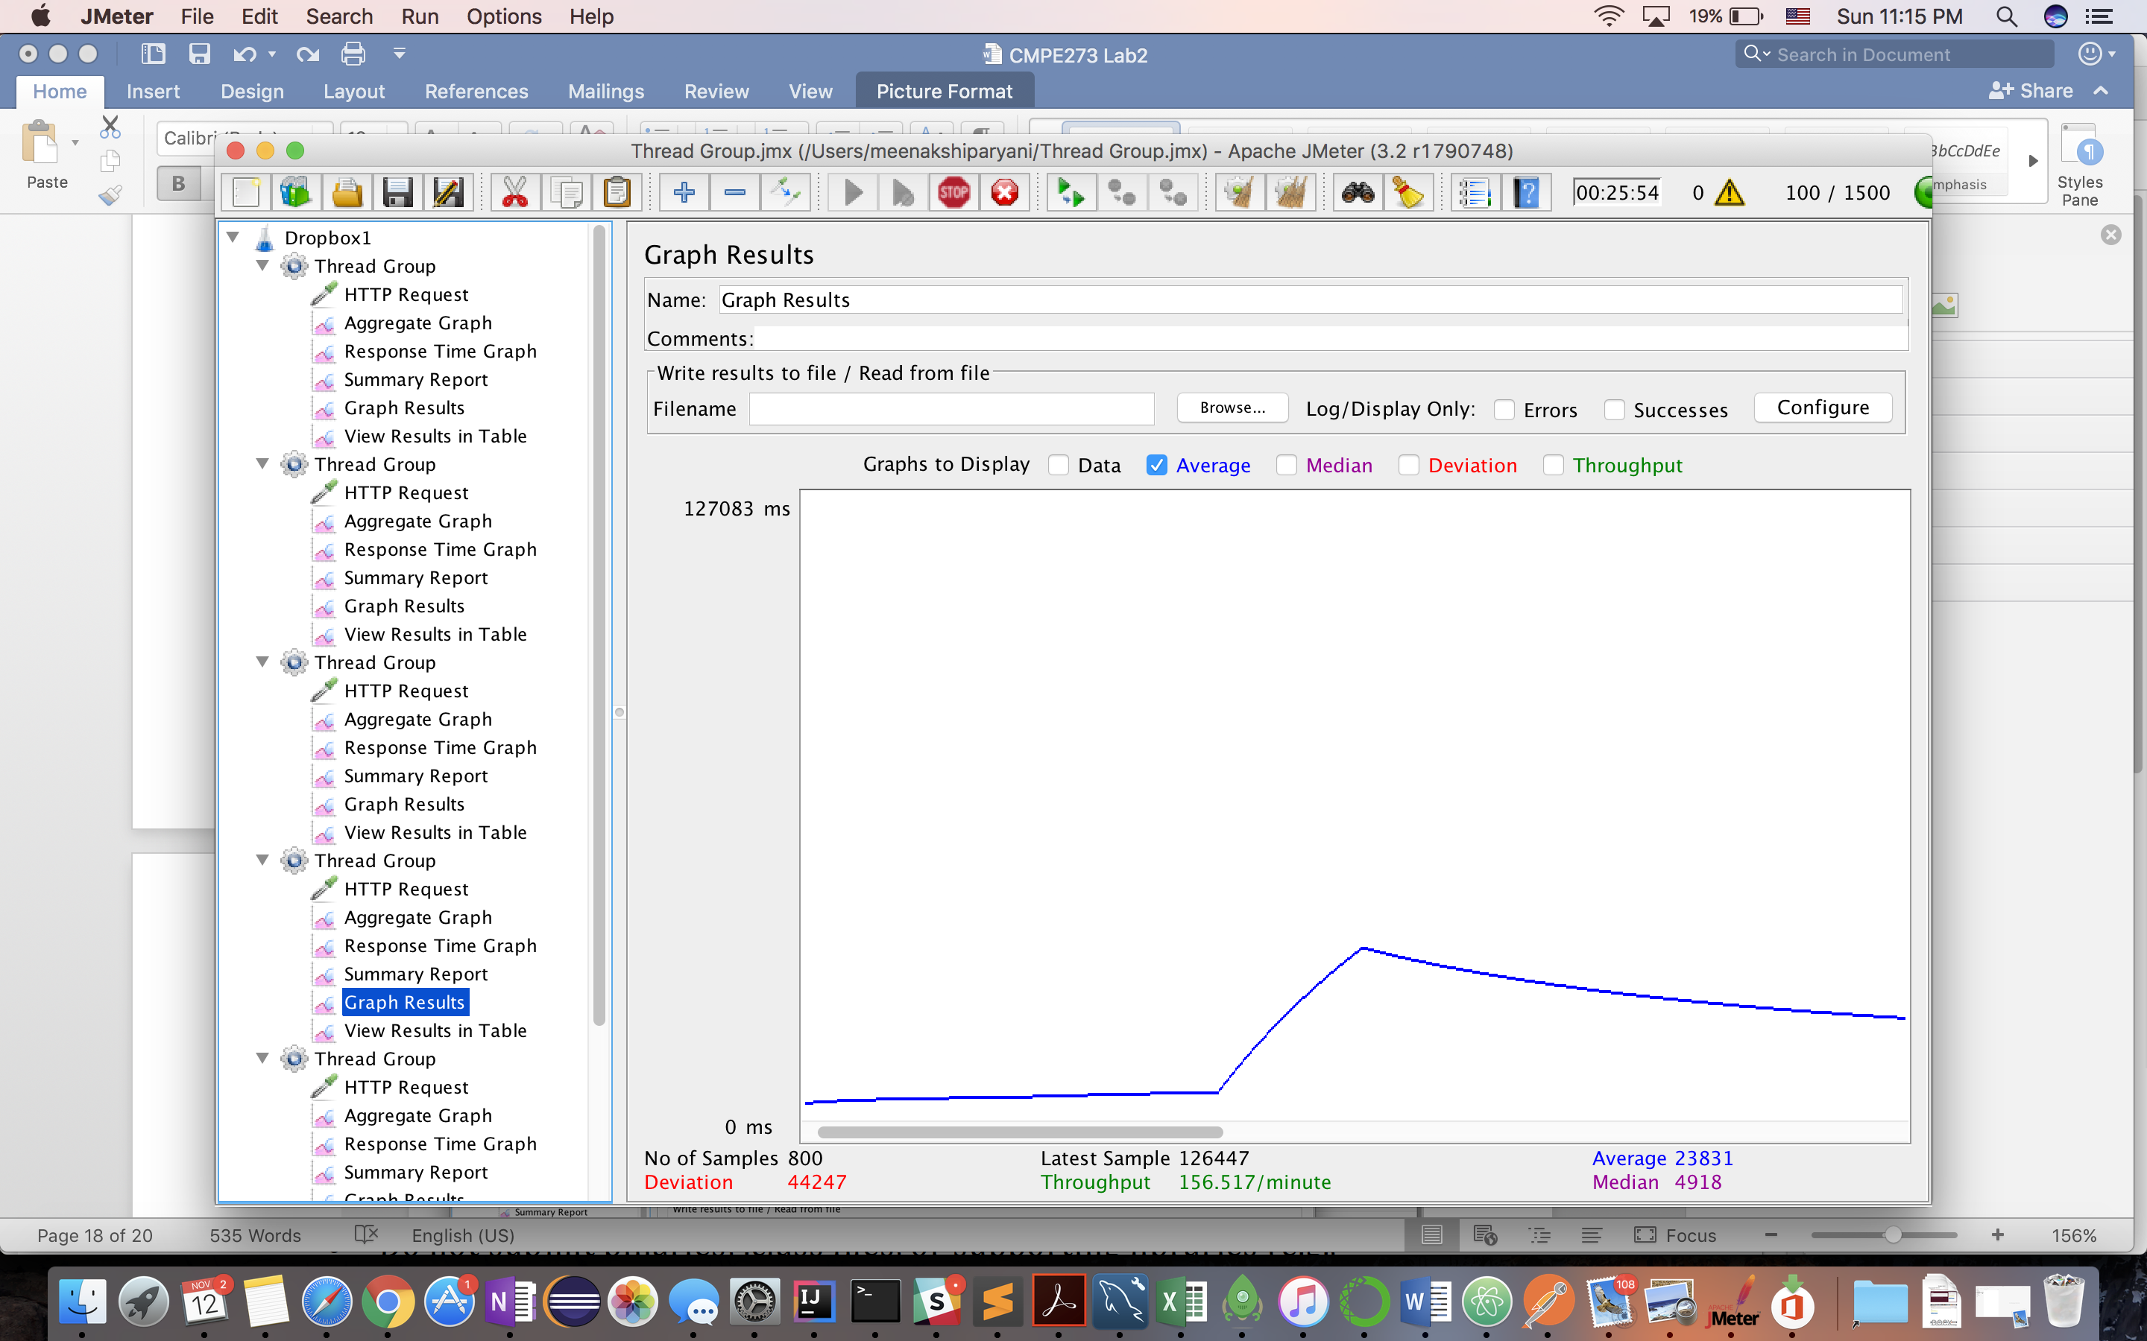

**500 Concurrent Users:**

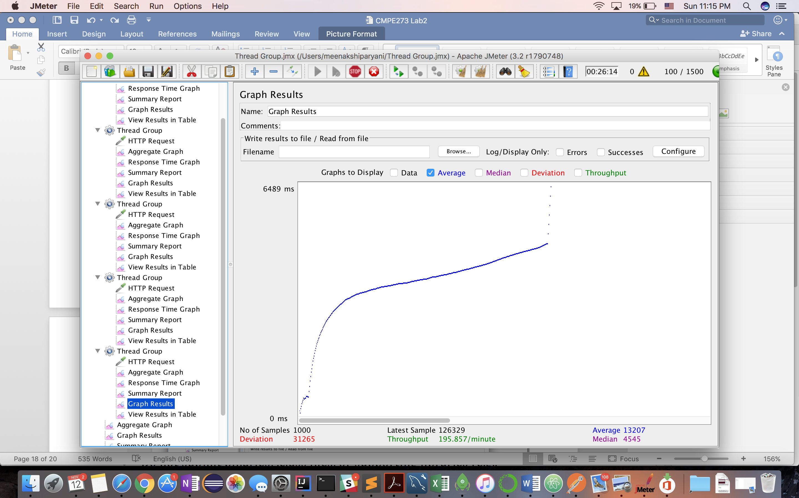

**Observation**: (**Q2 Answer**)

The average response time decreased as the number of requests increased and the overall throughput increased with more number of requests coming in. Kafka performs better with high number of incoming request as opposed to low number of requests. The average response time remained constant with low concurrent requests and abnormally high throughput.

Without Kafka services, the average response time increased as the number of concurrent user requests increased. Thus, Kafka is used to increase the performance of the system which is scalable and can be used to make a system scalable which is not already. Thus by including Kafka layer in our application, we have increased the scope of scalability by deploying services on multiple server in a micro-service fashion and thus the resultant system will be highly available and scalable and can accommodate many requests at a time.

**Q.3 - If given an option to implement MySQL and MongoDB both in your application, specify which data of the applications will you store in MongoDB and MySQL respectively**

It is common to use MySQL as primary storage and MongoDB as caching or intermediate storage for speed. It is advisable to have read intensive data in MongoDB for e.g user login information which is written only once and read thousands of times. So, for this kind of data, if stored in MongoDB, could yield faster performance due to many reads.

On the other hand, the data which is very write sensitive for e.g user files and groups information which are expected to be written to the database most than any other data for dropbox since file read and write are the primary functionalities involved here.

So, to have a more efficient system with Dropbox, we could have divided the data storage among MySQL and MongoDB. With MongoDB storing the read intensive data like user login, authentication and session information and MySQL being used for write intensive data like file/group functionalities.

**Read Me – included in Project folder**

**#### Steps for installing the project**

**Checkout this repo, install dependencies, then start the gulp process with the following:**

**> git clone https://github.com/MeenakshiParyani/Kayak.git**

**> cd front-end**

**> npm install**

**> npm install -g web-pack**

**> npm start**

**> cd back-end**

**> npm start**

**> cd kafka-backend**

**> npm start**

**#### List of Kafka Topics to be created**

**> login_topic**

**> signup_topic**

**> file_list_topic**

**> file_download_topic**

**> new_folder_topic**

**> sign_out_topic**

**> upload_file_topic**

**> share_file_topic**

**> star_topic**

**> create_group_topic**

**> add_member_topic**

**> remove_member_topic**

**> show_grouo_member_topic**

**> delete_group_topic**

**> rensponse_topic**